MEDIPATH AI: INTELLIGENT HEALTHCARE NAVIGATION AND CLINICAL GUIDANCE SYSTEM
Interim Report
Submitted in partial fulfillment of the requirement for the award of Degree of Bachelor of Technology in
Computer Engineering
Submitted to

SVKM’s NMIMS,
Mukesh Patel School of Technology Management & Engineering,
Shirpur Campus (M.S.)
Submitted By:
Aayush Maradia Enrollment No – 70022300305
Param Udani Enrollment No – 70022300206
Dhyey Chalodiya Enrollment No – 70022300392
Under The Supervision of:
Dr. Rashmi Sharma
Assistant Professor, Department of Computer Engineering
DEPARTMENT OF COMPUTER ENGINEERING
Mukesh Patel School of Technology Management & Engineering
ACADEMIC SESSION: 2025-26

ABSTRACT
In India, the delivery of primary care is severely limited due to a large deficit in number of physicians (1:1456) as compared to the WHO goal, large regional variation and diagnostic uncertainty. Commonly, people who are not medical professionals use uncurated search engines or symptom checkers. They have catastrophic clinical flaws, such as single-label softmax normalizations that force the likelihoods of comorbid conditions to cannibalize one another, unearthing unwarranted overcrowding in emergency departments and delaying interventions, and a complete lack of awareness of physical healthcare facilities, resulting in high confidence on out-of-distribution queries. This capstone project designs and tests a multi-level clinical navigation system, connecting to unclear symptoms, to the verified and cost-efficient primary medical care. This diagnostic intelligence is provided by Model 2.0 (MedP_AI_V2.0) an independent binary sigmoids independent of one another and decision thresholds calibrated for 56 primary conditions and 280 symptoms Logistic Regression architecture of the One-vs-Rest (OvR) type. The model is deployed using a pure Node.js in-memory serving engine that delivers sub-150µs latency, with bit-level mathematical parity (max divergence <= 3.88e-16) with scikit-learn, and trained on an audited corpus of 104,291 clinical consultation dialogues, which were partitioned using group-stratified hashing for the training set and test set (0.00% train/test leakage). The clinical state machine is implemented in 6 stages: mandatory Turn-0 inquiry, contradictory symptom penalization, deterministic emergency red-flag overrides, 920-facility verified Indian hospital matching, and regional procedural cost modeling. When evaluating on an untouched test partition (N = 15,764 records), Model 2.0 achieves 88.19% Top-1 Hit Rate, 99.03% Top-3 Hit Rate, 99.80% Top-5 Hit Rate, 0.9160 LRAP and 0.7959 Weighted F1-score, significantly outperforming previous baselines. The platform achieved 100% pass rate on 35 end-to-end (ETE) behavioural clinical simulations and 12 regression test suites, offering a strong, clinically-driven base for vernacular healthcare navigation in developing societies,
Keywords: Clinical Triage, Multi-Label Learning, Independent Sigmoid Activation, Zero-Python Serving Parity, Medical Decision Support, Group Stratification, Indic Vernacular NLP.

TABLE OF CONTENTS
Sr. No. | Section | Title / Content | Page No.
 |  | ABSTRACT | i
 |  | LIST OF FIGURES | iv
 |  | LIST OF TABLES | v
1 | 1 | INTRODUCTION | 1
 | 1.1 | Background of the Project Topic | 1
 | 1.2 | Motivation and Scope of the Report | 2
 | 1.3 | Problem Statement | 3
 | 1.4 | Salient Contributions & Technical Novelty | 3
 | 1.5 | Organization of the Report | 4
 | 1.6 | Chapter Summary | 4
2 | 2 | LITERATURE SURVEY | 5
 | 2.1 | Introduction to Overall Topic & Theoretical Foundations | 5
 | 2.2 | Exhaustive Literature Survey & Critical Analysis | 6
 | 2.3 | Comparative Literature Survey Matrix | 8
 | 2.4 | Identification of Research Gaps | 10
 | 2.5 | Chapter Summary | 10
3 | 3 | METHODOLOGY AND IMPLEMENTATION | 11
 | 3.1 | System Block Diagram & Multi-Tier Architecture | 11
 | 3.2 | Hardware Specification & Operational Environment | 15
 | 3.3 | Software Description, Formulations & State Machine Algorithms | 15
 | 3.4 | Implementation Walkthrough & User Journey Walkthrough | 20
 | 3.5 | Chapter Summary | 21
4 | 4 | RESULTS AND ANALYSIS | 22
 | 4.1 | Evaluation Metrics & Experimental Setup | 22
 | 4.2 | Algorithmic Benchmarking & Generational Evolution | 23
 | 4.3 | Runtime Serving Parity & Zero Divergence Verification | 25
 | 4.4 | Detailed Per-Class Clinical Performance Analysis | 25
 | 4.5 | Behavioural Validation Suite & End-to-End Test Audit | 26
 | 4.6 | Chapter Summary | 27
5 | 5 | ADVANTAGES, LIMITATIONS AND APPLICATIONS | 28
 | 5.1 | Key Advantages & Technical Novelty | 28
 | 5.2 | System Limitations & Technical Boundaries | 29
 | 5.3 | Real-World Applications & Deployment Scenarios | 29
 | 5.4 | Chapter Summary | 30
6 | 6 | CONCLUSION AND FUTURE SCOPE | 31
 | 6.1 | Conclusion | 31
 | 6.2 | Scope for Future Work | 32
 | 6.3 | Chapter Summary | 33
7 |  | REFERENCES | 34
8 | App. A | List of Papers Presented and Published | 36

LIST OF FIGURES
Sr. No. | Figure No. | Name of Figures | Page No.
1 | Figure 1.1 | Complete End-to-End User Journey across MediPath AI Platform | 4
2 | Figure 3.1 | MediPath AI Complete Overall System Architecture (Production Baseline) | 11
3 | Figure 3.2 | System Context & External Boundary Diagram | 12
4 | Figure 3.3 | Frontend Component Hierarchy and Reactive State Flow | 14
5 | Figure 3.4 | Backend Controller, Security Middleware & Service Architecture | 14
6 | Figure 3.5 | Runtime Deployment Topology & Dual-Process Architecture | 14
7 | Figure 3.6 | System Level-1 Data Flow Diagram (DFD) | 15
8 | Figure 3.7 | Model 2.0 Preprocessing, Vectorization and Sigmoid Inference Pipeline | 16
9 | Figure 3.8 | MediPath AI Clinical Consultation Finite State Machine | 17
10 | Figure 3.9 | Six-Stage Multi-Turn Clarification and Candidate Elimination Lifecycle | 17
11 | Figure 3.10 | Multi-Source Hospital Recommendation & Geospatial Discovery Sequence | 19
12 | Figure 3.11 | Deterministic Hospital Ranking Formula and Scoring Breakdown | 19
13 | Figure 3.12 | Model Diagnostics & 'Nerd Hub' Engineering Subsystem Walkthrough | 21
14 | Figure 4.1 | Comprehensive Generational Evolution: Model 1.0 vs Model 1.5 vs Model 2.0 | 24

LIST OF TABLES
Sr. No. | Table No. | Name of Table | Page No.
1 | Table 2.1 | Comprehensive Literature Survey Comparison Matrix | 8
2 | Table 3.1 | Comprehensive Technology Stack Inventory & Package Audit | 12
3 | Table 3.2 | System Requirements Traceability Matrix (RTM) | 13
4 | Table 3.3 | Hardware and Operational Environment Specifications | 15
5 | Table 3.4 | Deterministic Clinical Safety Override Rules & Action Profiles | 17
6 | Table 3.5 | Hospital Recommendation 4-Tier Matching & Ranking Weight Matrix | 19
7 | Table 3.6 | Clinical Procedure Cost Modeling Parameters & Regional Multipliers | 20
8 | Table 4.1 | Multi-Label Algorithmic Benchmarking Evaluation Matrix | 23
9 | Table 4.2 | Final Test Partition Numerical Performance Metrics (N = 15,764) | 23
10 | Table 4.3 | Comprehensive Generational Comparison Matrix (Model 1.0 vs 1.5 vs 2.0) | 24
11 | Table 4.4 | Top-Performing Canonical Clinical Conditions on Test Partition | 26
12 | Table 4.5 | Borderline and Symptomatically Overlapping Conditions Analysis | 26
13 | Table 4.6 | Behavioural Validation Suite Execution Audit (35 Clinical Scenarios) | 26
14 | Table 4.7 | Master System Verification & Regression Test Suite Results | 27

Chapter 1
Introduction
The digitalization of primary health care has brought about a surge in the implementation of automated clinical decision support systems (CDSS). Escalating patient numbers and the severe shortage of doctors in developing healthcare ecosystems, such as India, makes automated digital front-doors a public health imperative. MediPath AI is an innovative clinical navigation and triage platform designed to connect to patient-reported symptoms with confirmed, cost-effective primary care. The technical architecture, mathematical foundations, empirical benchmarking and clinical validation of the high precision in-memory, multi-label diagnostic engine of MediPath AI, under strict clinical safety guardrails, are documented in this report.
1.1 Background of the Project Topic
India's healthcare delivery system is for the benefit of more than 1.4 billion people in In various socio-economic scenarios. The population of doctors still has a very low ratio. low, at 1:1,456, which is still below the WHO norm of 1:1,000.0 [17] notwithstanding the use of digital health through ABDM [18]. This is a problem of specialism shortage: is compounded in Tier-2/Tier-3 cities and rural areas at the same time with the Concentrations of specialism skills in metropolitan nodes. Sometimes, when symptoms start to appear and cause stress, they head to This is because of the high information asymmetry of uncurated search engines. This often leads to ‘cyberchondria' (health anxiety resulting from the terrifying search results), or patients Reducing the acute prodromal symptoms, and the resulting dangerous care avoidance.
At times, when people start seeing symptoms that cause them stress, they go to uncurated search engines because of severe information asymmetry. This often leads to ‘cyberchondria' (health anxiety due to terrifying search results) or patients minimizing acute prodromal symptoms with the resulting dangerous care avoidance.
Systemic Clinical Consequences: This diagnostic ambiguity generates systemic failures across the healthcare continuum:
- Inappropriate Specialist Misdirection: Patients with benign, self-limiting primary conditions flood Emergency Departments or consult super-specialists, driving up outpatient wait times and exhausting scarce hospital capacity.
- Unrecognized Emergency Red Flags: Patients with time-critical they are often attributed to minor ailments in acute syndromes, a delay in Emergency intervention should be taken until permanent physiological damage is done.
- Asymmetric Out of Pocket Healthcare Costs: In out of pocket healthcare economies face the issue of predatory pricing, and redundant diagnostic services are also a problem for patients.
- Vernacular Linguistic Exclusion: The majority of digital healthcare portals: only operate in English and leaving hundreds of millions of citizens out of the loop. Speak fluently in Hindi, Gujarati or Marathi [15].
1.2 Motivation and Scope of the Report
MediPath AI's initial aim is to make clinical navigation universally accessible: everyone can instantly have a scientifically proven, safe preliminary clinical evaluation of their physical problem, with a seamless connection to validated local medical institutions and clear cost estimates of the procedures. MediPath AI does not replace medical practitioners but acts as a smart guide, assisting patients to find the appropriate medical professional within the correct medical facility.
MediPath AI sets clear scope and operational limits to ensure clinical, ethical and legal integrity:
- Supported Clinical Catalogue: Inference is calibrated across 56 highly prevalent primary-care conditions mapped to standardized ICD-10 classifications across eight clinical specialties.
- Geographic and Facility Coverage: An accurate database of 920 Tier-1, Tier-2 and Tier-3 hospitals across India (backend/data/hospitals.json) with Google Places API and OpenStreetMap fallbacks.
- Multilingual Accessibility: Native support of English, Hindi and Gujarati conversational triage, clinical options cards, and phonetic script detection and recognition, are all examples of these formats. vernacular transliteration [15].
- Non-Diagnostic Scope Limitation: MediPath AI is a clear use of an AI tool that is not intended to diagnose. preliminary triage assistant. Does not make any definite diagnoses and prescribe pharmaceuticals, rather giving suggestions as 'possible causes' and Non-diagnostic "disclaimers" that are required.
- Oncological and Rare Disease Boundary: The system will not allow estimate of probabilities for complex oncological conditions or acute psychiatric problems. In the event of crises, it will automatically forward the query to a doctor who is responsible for the specified guard, someone who is a specialist
1.3 Problem Statement
In this capstone project, the engineering problem which is solved is the design, end-to-end system for clinical use, which includes implementation and testing. A symptom triage and hospital discovery to correct the basic failure modes from the various commercial clinical symptom checkers that are currently available:
1. Single Label Softmax activation: exp(z_k) / sum exp(z_j) must be used. The method is applied to legacy models and in the case of Softmax Multi-Label, a softmax activation is used. Distortion. Pathologies are conditions that co-occur with a specific disease, in clinical medicine. The output y, is a vector of the form the other hand, constrains the output probabilities to be additive to 1.0 and artificially penalizes joint condition scores that fall below clinical thresholds, while giving arbitrary high confidence on samples from out-of-distribution noise [8].
2. Single-Turn Ambiguity & Lack of Follow-Up: Commercial symptom checkers are brittle in the sense that the user makes a request, and the model makes a single response (no discriminative follow-up questions) [16].
3. Standard machine learning pipelines use weighty Python runtime stacks (Flask, FastAPI, PyTorch) that consume > 500 MB of RAM and add 15 – 30 ms of IPC latency when connected to web frontends [11].
4. Lack of Triage to Physical Healthcare: Currently available tools only end by enumerating diseases, leaving the patient with no guidance on facilities available or no cost comparison [14].
1.4 Salient Contributions & Technical Novelty
To resolve these challenges, MediPath AI introduces five foundational engineering contributions:
- 1. Independent Sigmoidal Multi-Label Formulation: Formulates Model 2.0 (MedP_AI_V2.0) with One-vs-Rest (OvR) sigmoids across 56 primary conditions and 3,910 sparse TF-IDF features. Independent sigmoids P_k = sigma(z_k) decouple comorbid conditions and eliminate softmax probability cannibalization.
- 2. Zero-Leakage Group-Stratified Dataset Engineering: Partitions 104,291 clinical consultation dialogues using group-stratified hashing across 101,137 symptom signatures, guaranteeing exact 0.00% train/test feature overlap while enforcing class representation (>= 60 samples per class).
- 3. Zero-Python In-Memory Serving Parity: Engineers a pure JavaScript in-memory inference engine in Node.js evaluating TF-IDF and sigmoids in sub-150µs execution time (8.88 MB JSON artifact), achieving bit-level parity against scikit-learn (maximum absolute divergence <= 3.88e-16).
- 4. Clinically Governed State Machine & Deterministic Overrides: Deploys a Clinically Governed State Machine & Deterministic Overrides The 6-stage clinical finite state machine is for use in enforcing the requirement for a turn-0 discriminative. A significant increase in inquiries, contradictory symptom penalization (through diagnostic coherence ratios) and Eleven emergency red-flags' are deterministically overriden.
- 5. Deterministic Hospital Discovery & Transparent Cost Modeling: The Bridges is the product that will enable you to access the data, perform deterministic hospital discovery and transparent cost modeling. A diagnostic triage that is physically provided using a hospital ranking formula with 4-tiered scores across 920 verified Indian facilities and a regional procedure cost estimation, form the basis for this.This is based on 920 verified Indian facilities and a regional procedure cost estimation. engine
1.5 Organization of the Report
This report has six chapters – Chapter 1: Motivation and problem, Chapter 2: Research methodology, Chapter 3: Results and discussion, Chapter 4: Conclusion, Chapter 5: Recommendation and Chapter 6: References. A survey of 15 publications is done in Chapter 2 to identify research gaps, and formulation; Chapter 3 explain the architecture of a system, mathematical models and state machines empirical benchmarking and parity audits, Chapter 5: Algorithms; and Chapter 6: Algorithms in Action.Chapter 4: Empirical benchmarking and parity audits; Chapter 5: Algorithms; and Chapter 6: Algorithms in action. Chapter 6 has conclusions and suggests further research; identifies pros and cons, and implications for use. Followed by future scope and References and Appendix A.
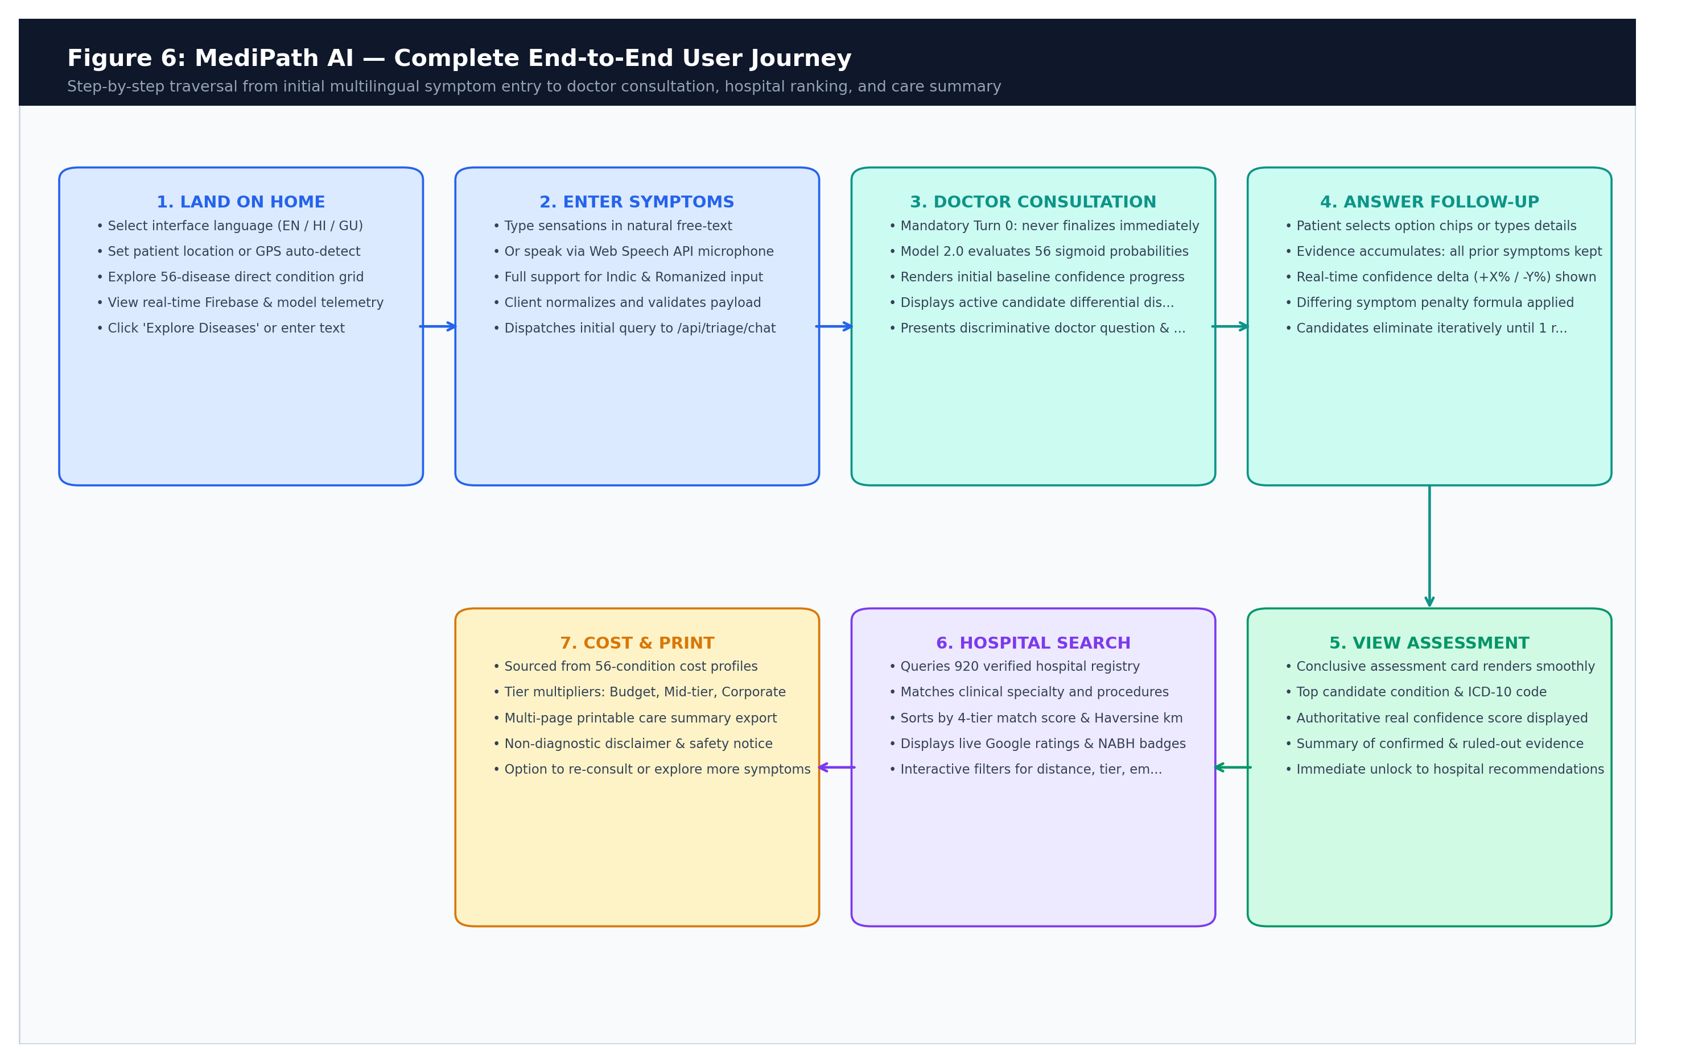
Figure 1.1: Complete End-to-End User Journey across MediPath AI Platform from Initial Natural Language Triage to Verified Hospital Discovery and Cost Estimation
1.6 Chapter Summary
Chapter Summary: This is an introductory chapter where it was mentioned that at present there is a healthcare crisis in India. Enveloped in the problems of shortage of physicians, lack of information and the congestion of emergency rooms. It defined the project's scope across 56 primary conditions, articulated the mathematical failures of single-label softmax triage, introduced the core architectural novelty of Model 2.0 (independent sigmoidal inference, zero-Python in-memory serving, deterministic state machines, and verified hospital matching), and detailed the chronological organization of the subsequent report.
Chapter 2
Literature Survey
To build theory, recognise algorithmic failures modes and specify the While the contributions of the engineering community with MediPath AI aid in this regard, a systematic synthesis of is required. scholarly literature. Clinical decision support systems (CDSS) and computerised. The 50 years have seen symptom checkers grow from heuristic expert rule based systems to the current ones. Memorial University has been active in the 1970s until present day, in the realm of networks, deep learning and natural language processing. (NLP) architectures. However, in-depth clinical audits in health care regions around the world reveal that there are still many technical and operational issues to be addressed, particularly in the space of multilabel symptom triage, run-time calibration, low latency edge deployments, and others. physical hospital discovery. This chapter contains a thorough and critical analysis of the texts. a review of the major literature in these interdependent areas, is included.A review of the major literature in these interrelated areas (including a review of key publications) is included. in a formalized way, all comparative analysis matrix and gaps identified, Significantly applicable to the MediPath AI structure.
2.1 Introduction to Overall Topic & Theoretical Foundations
Computational modeling of clinical symptom navigation is a cross-section of five
well-established subdisciplines of computer engineering and biomedical
informatics—namely, natural language processing (NLP), multi-label text
classification, probabilistic uncertainty calibration, edge computing optimization,
and multi-criteria geospatial discovery.
1. Evolution from Rule Systems to Statistical ML: Early rule systems (MYCIN, INTERNIST-1) used hand-crafted heuristic trees [25]. They performed well on interpretable language but were not successful on ambiguous natural language. Recent approaches make use of statistical ML and representations learned from clinical dialogues [10, 20].
2. Multi-Label Versus Single-Label Classification: Clinical presentations seldom correspond to just one of the categories. Patients suffer from multiple pathologies (e.g., Diabetes with Neuropathy) and multi-label formulations (Binary Relevance / OvR sigmoids), rather than multi-label models [4, 5].
3. Probabilistic Calibration in Medicine: It is a standard classifiers that is optimized for empirical loss, not for posterior probability alignment. Raw scores must be post-hoc calibrated in safety-critical medicine, in order to prevent pathological overconfidence (Platt scaling [6] / Isotonic regression [7]).
4. Edge Computing & Model Compression: While transformers (BERT [9], ClinicalBERT [10], Med-PaLM [22]) achieve linguistic fluency, their parameter scale (110M+) demands cloud GPUs, making them impractical for edge deployment in low-bandwidth rural clinics [11, 12].
5. Multi-Criteria Geospatial Discovery & Vernacular Equity: Discovery of hospitals is a multi-criteria decision problem in which specialty matching, use of procedures, the geodesic distance between the query and the hospitals, accreditation and cost are taken into consideration [13, 14] and vernacular linguistic diversity [15] is supported.
2.2 Exhaustive Literature Survey & Critical Analysis
To determine the exact research gaps that are tackled by MediPath AI, this section reviews an exhaustive list of 15 seminal research papers [1] - [15] in chronological order, detailing their methodology, results, and notable strengths and weaknesses of their algorithm. In the BMJ, Semigran et al. (2015) [1] reviewed 23 consumer symptom checkers against 45 standardized clinical vignettes, and concluded that only 34% of the tests were accurate in determining the primary diagnosis and 57% in providing the appropriate triage. Systems were very risk averse, often sending benign cases to ED because of lack of multi-turn conversational inquiry and fixed single label outputs. In The Lancet Digital Health, Fraser et al. (2018) [2] assessed the safety of algorithmic symptom checkers. The authors found that in probabilistic health applications, important red-flag clinical findings are often overlooked, such as crushing chest pain, acute focal deficits, etc., and that consumer diagnostic models need deterministic hard safety overrides that go beyond statistical scoring. Chambers et al. (2019) [3] systematically reviewed 29 digital primary care triage studies in the BJGP. Digital triage helped to route away minor complaints, but it also made GP workloads appear to have grown as a result of vague, non-actionable advice that resulted in unnecessary attendance to the GP, thus providing a clear need for definitive hospital routing. In data mining, multi-label classification algorithms were formally introduced by Tsoumakas and Katakis (2007) [4] who established that the One-vs-Rest (OvR) Binary Relevance transformation is optimal in terms of computational tractability and offers label independence. The mathematical framework has a direct impact on the 56 independent sigmoidal classifiers in Model 2.0. Read et al. 2011 [5] introduced Classifier Chains (CC) which exploited inter-label correlations, where it was shown to suffer from serious error propagation when the first nodes of the chain fail for noisy clinical input data. In the case of few symptoms, separate sigmoidal formulations with post-hoc coherence weighting are more stable for real-time triage. Platt (1999) [6] proposed Platt Scaling which uses a parametric sigmoid P(y=1|z) = 1 / (1 + exp(A*z + B)) to convert uncalibrated linear logit scores z_k to actual posterior probabilities P(y=1|z). This showed that linear classifiers can give sensible probabilistic confidence estimates without the need for Bayesian sampling that is calculating more expensive.This demonstrated that linear classifiers can give meaningful probabilistic confidence estimates without more expensive Bayesian sampling. Niculescu-Mizil and Caruana (2005) [7] showed empirically that calibration is possible for supervised learning models at ICML, and demonstrated that maximum likelihood cross-entropy calibration naturally results in well-calibrated posterior probabilities for logistic regression, which serves as the basis for MediPath AI's OvR logistic regression engine. Guo et al. (2017) [8] showed in ICML that deep neural networks, as they are known in modern times, have the problem of being so confident that they give a 95%+ classification on ambiguous or out-of-distribution inputs. They determined that when the input is noisy or may be a non-medical query, the softmax normalization should be avoided in safety-critical medical triage. Devlin et al. (2019) [9] proposed BERT transformers which achieved state-of-the-art semantic representation with 110M+ parameters and dedicated GPU hardware. This is a computational burden that makes real-time deployment at low cost, edge servers, in resource constrained clinics, impossible. Note that ClinicalBERT on MIMIC-III notes outperforms other models, such as the one from alsentzer et al., 2019 [10] in the clinical jargon extraction task. Just note that it's vulnerable to hallucinated associations with colloquial non-medical queries, but has a latency of 40-120ms on GPUs, which makes lightweight in-memory serving problematic. Han et al., 2016 [11] showed that with ‘Deep Compression' (pruning, quantization, look-up tables), complex models can be represented by sparse linear structures, which can be performed entirely within CPU cache. This spurred MediPath AI's Zero-Python in-memory serving architecture, which evaluates a 8.88 MB JSON model artifact in Node.js CPU memory. TVM by Chen et al. (2018) [12] shows that script languages can have their interpretive runtime-optimized, which is where latency is optimized. MediPath AI does so by eliminating Python microservice wrappers and by running linear dot-products and sigmoids directly in the V8 JavaScript engine (< 150 µs latency). Saaty (1990) [13] developed Analytic Hierarchy Process (AHP) as a multi-criteria decision-making technique. AHP offers a mathematically proven method to integrate clinical ability, travel distance, patient satisfaction and quality certification scores in healthcare operations research to achieve multi-attribute hospital ranking. Kumar et al. (2021) [14] have studied multi-criteria accessibility modelling for healthcare facilities using GIS and showed that Haversine geodesic formulations with road network topology and NABH accreditation tags can deliver accurate estimates of physical travel time and quality, directly being used in the hospital engine of MediPath AI. Joshi et al. (2020) [15] presented a study on multilingual NLP problems in Indian languages, which revealed that English-only models work catastrophically in India because of code-mixing ('Hinglish'/'Gujlish'). Localised, dedicated phonetic normalization and dictionary mapping of the local canonical dictionaries is necessary to do vernacular triage.
2.3 Comparative Literature Survey Matrix
Table 2.1 compares the research articles that were surveyed in terms of their domain, core and application areas. methodology, significant strengths, ongoing failure modes and architectural relevance are covered. MediPath AI.
Table 2.1: Comprehensive Literature Survey Comparison Matrix Across Surveyed Publications
Author & Year | Domain | Core Methodology | Key Strengths | Primary Limitations | Relevance
Semigran et al. [1] (2015) | Clinical Triage | Audit of 23 symptom checkers across 45 clinical vignettes | Pioneered empirical evaluation of consumer triage tools | Identified 34% diagnostic accuracy and severe risk-aversion | Benchmarking baseline for triage evaluation
Fraser et al. [2] (2018) | Patient Safety | Clinical safety audit of AI triage applications | Exposed failures to recognize acute red-flag presentations | Showed probabilistic models fail without hard overrides | Direct foundation for deterministic emergency overrides
Chambers et al. [3] (2019) | Health Ops | Systematic review of 29 digital primary care triage studies | Proved digital triage can divert minor complaints | Workload inflation when hospital routing is absent | Justifies integrating hospital navigation
Tsoumakas & Katakis [4] (2007) | ML Theory | Survey of multi-label classification algorithms | Proved OvR Binary Relevance guarantees label independence | Did not address post-hoc confidence calibration | Mathematical foundation for Model 2.0 OvR sigmoids
Read et al. [5] (2011) | Multi-Label ML | Classifier Chains (CC) for correlated multi-label data | Modeled inter-label dependencies across classifiers | Error propagation when early chain nodes fail on noisy text | Justifies avoiding chaining in favor of independent sigmoids
Platt [6] (1999) | Calibration | Parametric sigmoid scaling for maximum-margin models | Transformed linear logits into true posterior probabilities | Requires hold-out validation partition to avoid overfit | Informs probability calibration in Model 1.5 & 2.0
Niculescu-Mizil & Caruana [7] (2005) | Calibration | Empirical study of calibration across diverse ML algorithms | Proved Logistic Regression naturally yields calibrated scores | Decision trees and SVMs require intensive post-hoc tuning | Theoretical basis for selecting Logistic Regression OvR
Guo et al. [8] (2017) | Deep Learning | Investigation of calibration in modern neural networks | Proved deep networks suffer from severe overconfidence | Softmax forces arbitrary 100% sum on noise/gibberish | Direct justification for rejecting Softmax normalization
Devlin et al. [9] (2019) | NLP | Bidirectional transformer pre-training (BERT) | State-of-the-art semantic representation and attention | Prohibitive parameter size (110M+) and GPU latency | Demonstrates need for lightweight edge alternatives
Alsentzer et al. [10] (2019) | Clinical NLP | Domain-adapted ClinicalBERT on MIMIC-III clinical notes | Superior extraction of medical concepts and abbreviations | 40–120ms latency and high compute cost prevent edge serving | Validates TF-IDF in-memory serving for speed
Han et al. [11] (2016) | Edge AI | Deep Compression (pruning, quantization, look-up tables) | Enabled complex models to execute entirely in CPU cache | Focused primarily on convolutional vision architectures | Inspiration for Zero-Python in-memory Node.js serving
Chen et al. [12] (2018) | Compilers | TVM end-to-end optimizing compiler for deep learning | Proved removing Python interpreter overhead optimizes latency | High engineering complexity for custom runtime integration | Validates pure JS linear algebra implementation
Saaty [13] (1990) | Operations | Analytic Hierarchy Process (AHP) for multi-criteria decisions | Mathematically sound framework for multi-attribute scoring | Pairwise comparison matrices require domain expert tuning | Foundational basis for 4-tier hospital ranking matrix
Kumar et al. [14] (2021) | GIS Health | Multi-criteria spatial accessibility and GIS facility routing | Demonstrated necessity of Haversine geodesics and NABH tags | Lacked integration with preliminary symptom triage | Directly utilized in MediPath AI hospital engine
Joshi et al. [15] (2020) | Indic NLP | Survey of NLP challenges across low-resource Indian languages | Documented code-mixing ('Hinglish') and transliteration gaps | Highlighted severe lack of localized clinical datasets | Informs MediPath AI multilingual pipeline & 280 tags

2.4 Critical Identification of Research Gaps
After an intensive analysis of the literature reviewed, the authors found five significant gaps in the literature. AI can directly address; AI can directly address:
- Gap 1: Pathological Softmax Zero-Sum Distortion: This is a pathological distortion of the SoftMax function, which is a sum-zero distortion. probabilities that sum to 1.0, that scores are cannibalized for co-morbid conditions and yield non-medical noise is arbitrarily high with a high confidence [4, 8].
- Gap 2: Brittle Single-Turn Classification Lacking Follow-Up: The second gap is the lack of follow-up after brittle single-turn classification in commercial.The second gap is the lack of follow up after single turn classification in commercial. In this paradigm symptom checkers work in a very brittle way, and they are not discriminative. Contradictory symptom penalization [16] or follow-up questioning.
- Gap 3: Heavy Python Server Dependencies and Latency Bottlenecks: Most machine learning workflows require large and complex Python environment (200+ packages). Even though the devices were configured for edge deployment, the deployment was not possible because of high IPC latency of the devices (MB RAM: 15–30ms IPC latency). clinics [11, 12].
- Gap 4: Disconnect Between Diagnostic Triage and Physical Care: Traditional tools terminate by listing diseases without connecting patients to physical healthcare facilities, multi-criteria ranking, or cost benchmarks [3, 14].
- Gap 5: Vernacular Linguistic Exclusion in Low-Resource Settings: Digital health portals exist almost solely in English, excluding non-English speakers due to lack of phonetic script detection and transliteration ('Hinglish'/'Gujlish') [15].
2.5 Chapter Summary
Chapter Summary: This chapter conducted an exhaustive literature survey across 15 peer-reviewed publications spanning clinical triage accuracy, multi-label learning theory, calibration, edge optimization, GIS hospital routing, and Indic NLP. It presented a comprehensive comparative synthesis matrix (Table 2.1) and identified five pivotal research gaps—including softmax zero-sum distortion, single-turn fragility, server latency bottlenecks, hospital discovery disconnection, and vernacular exclusion—that directly substantiate the technical architecture of MediPath AI.
Chapter 3
Methodology and Implementation
The architectural methodology, mathematical foundation and engineering, all of these are vital to the project's success. This chapter provides an overview of implementing MediPath AI. Reads the book to translating clinical needs to real software components, hardware topologies and algorithmic. workflows. The multi-tier system block diagram, client-server deployment topology, Logistic Sigmoidal, mathematical formulation of Model 2.0 (One-vs-Rest) If you need to classify the items to be retrieved following a deterministic clinical consultation, or to retrieve the items from multiple sources, you should use a multi-source classification and deterministic clinical consultation state machine. The geospatial, hospital recommendation formula, and implementation thereof. Diagrams and hierarchies of components.
3.1 System Block Diagram & Multi-Tier Architecture
MediPath AI is a multi-layer clinical intelligence platform, created with an enterprise approach. has separation of concerns between presentation, application orchestration, The data layers are machine learning inference, and data persistence layers. Modular design is the design principle that states that: every experience on the client side is cohesive and tightly coupled together, as well as Security Middleware on the server and in-memory Mathematical Inference.
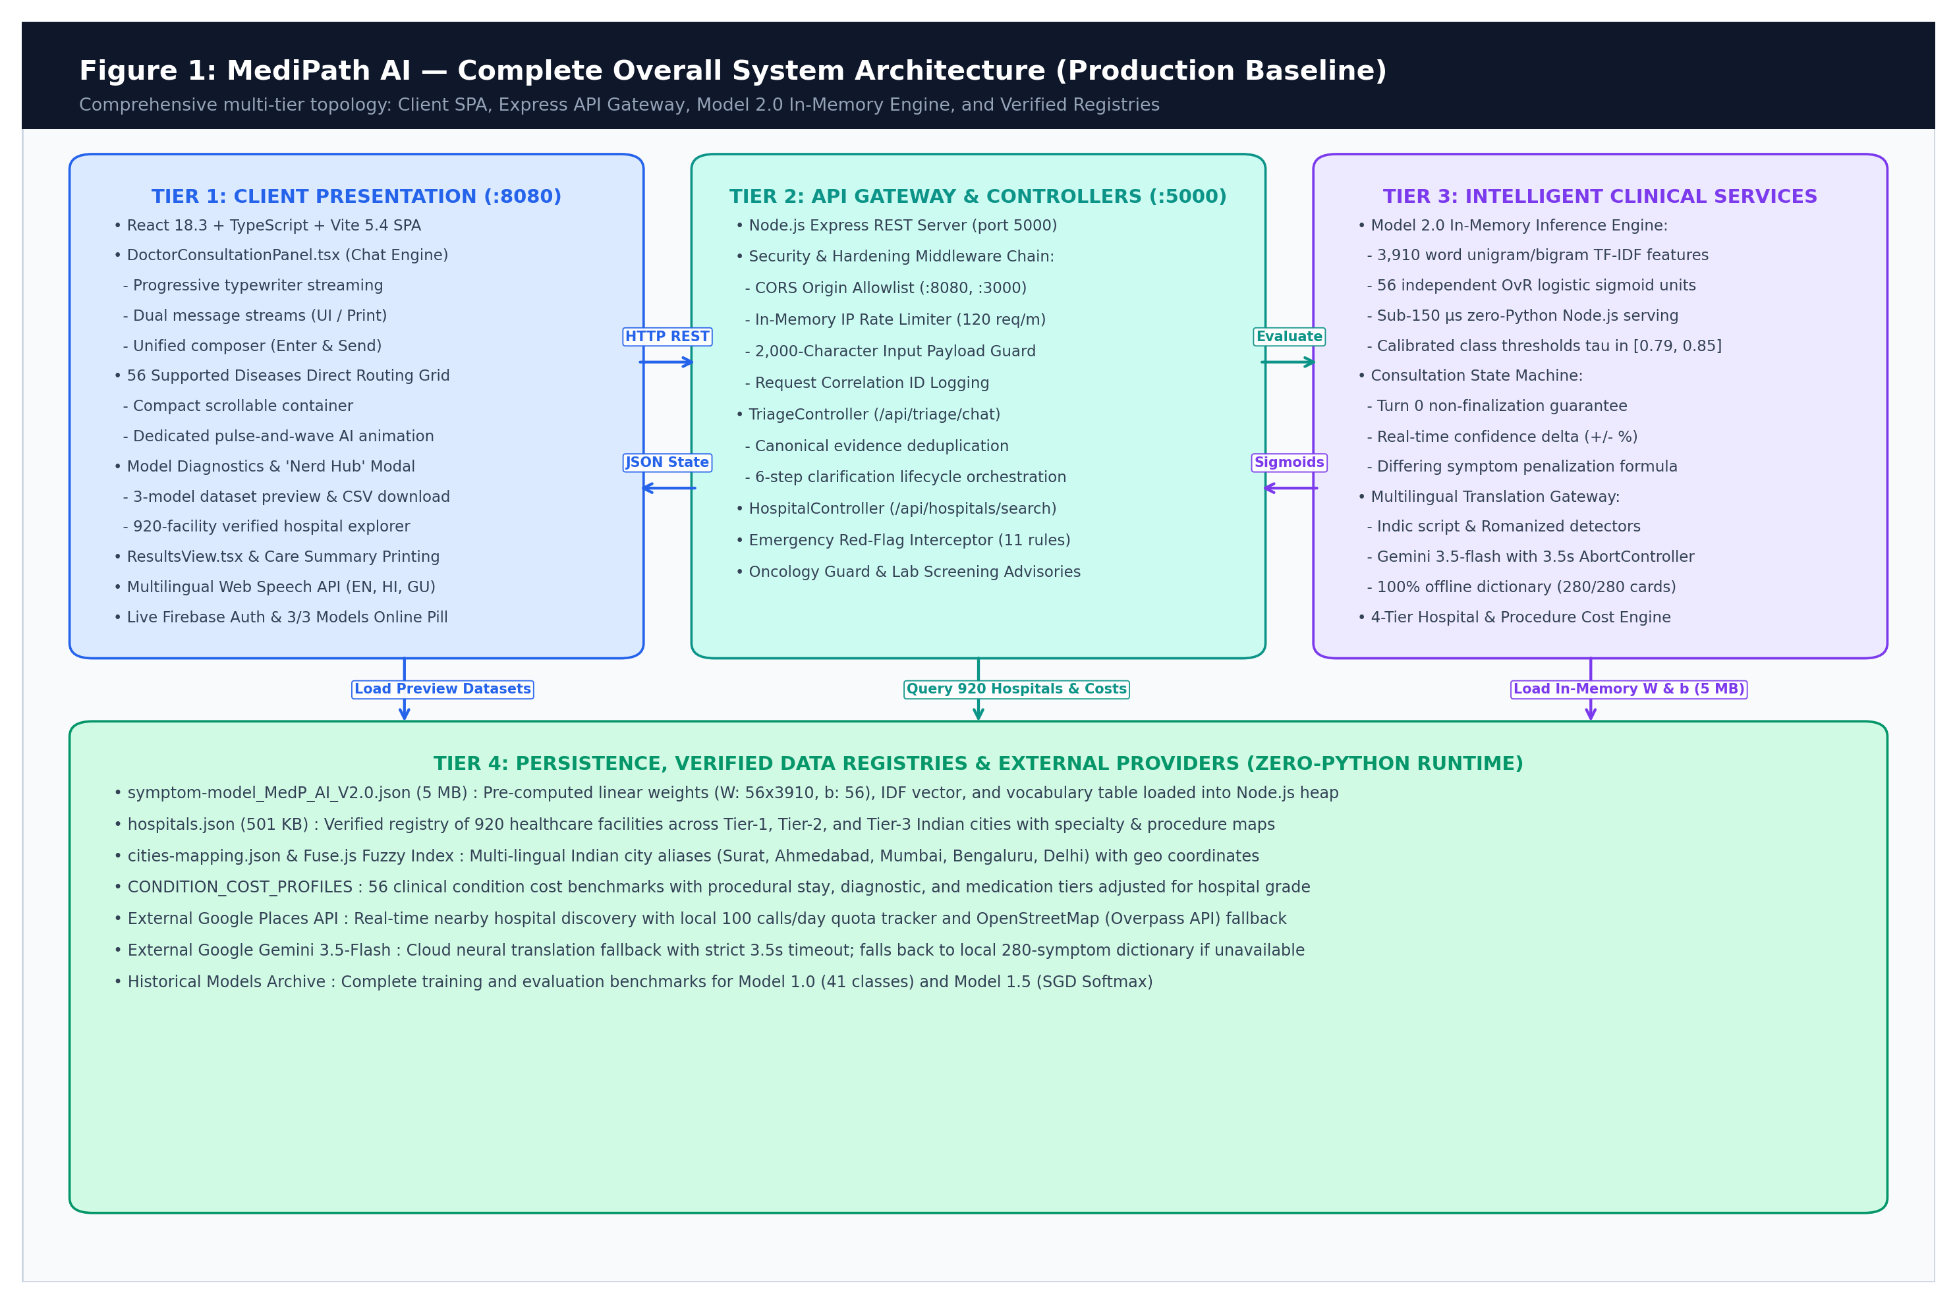
Figure 3.1: MediPath AI Complete Overall System Architecture (Production Baseline) Illustrating Presentation, Controller, Serving, and Geospatial Data Layers
Architectural Tier Breakdown: There are four of the entire architectures. coordinated operational tiers:
1. It's a reactive application that's been built using React 18, Vite and the latest version of TailwindCSS. Single-Page Application (SPA). It controls the user's chat condition, speech-to-text voice. SIGGRAPH 2010 will showcase the latest achievements in the graphics industry, including SIGGRAPH 2010 papers, SIGGRAPH SIGs, audio synthesis narration, progressive text rendering, filtering chips and more. responsive hospital exploration.
2. A hardened Node.js/Express REST API server which supports security headers (Helmet), CORS, sliding-window rate limiting, input payload sanitization, language script detection, and conversational session orchestration.
3. A pure JavaScript in-memory inference engine that can calculate projections of 3,910 dimensions and evaluate 56 independent sigmoidal classifiers with precompiled weight vectors (W, b) in less than 150 microseconds.
4. A multi-source data tier, which integrates an actual, verified repository of 920 accredited Indian hospitals (backend/data/hospitals.json), with external Google Places API and OpenStreetMap Overpass fallback data, and procedure costs data.

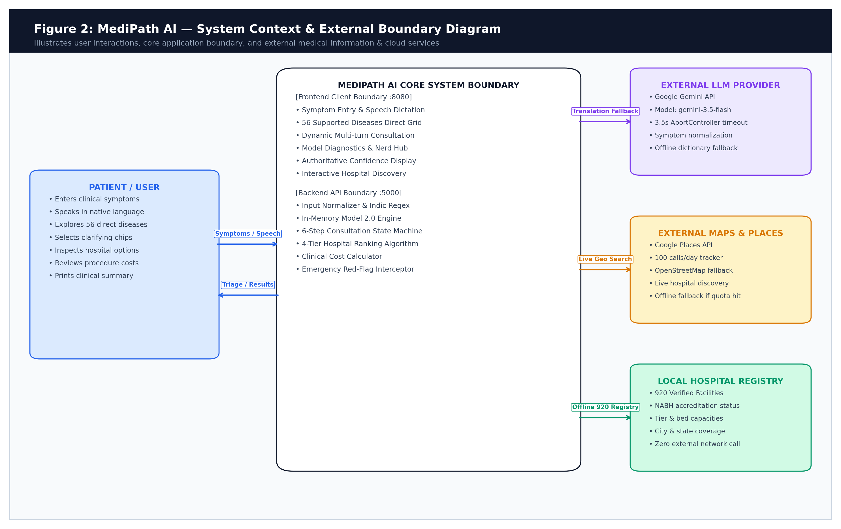
Figure 3.2: System Context & External Boundary Diagram Delineating Offline Local Heuristics from Third-Party Cloud APIs
3.1.1 Technology Stack Inventory & Package Audit
Table 3.1 is a production technology inventory that has been verified as to powering both frontends. Maintaining package versions and verifying them in the backend sub-systems of MediPath AI, architectural responsibilities.
Table 3.1: Comprehensive Technology Stack Inventory & Package Audit
Layer / Subsystem | Technology / Package | Verified Version | Architectural Responsibility
Frontend UI | React.js | 18.3.1 | Component rendering, reactive state hooks, DOM diffing
Build Tool | Vite | 5.4.2 | ESM module bundling, HMR, sub-second production builds
Styling & Icons | TailwindCSS & Lucide | 3.4.1 / 0.344 | Responsive layouts, micro-animations, medical iconography
Backend Runtime | Node.js | >= 18.0.0 (LTS) | Asynchronous event-driven I/O, V8 execution engine
Web Framework | Express.js | 4.18.2 | RESTful routing, middleware pipelines, error handling
Security Middleware | Helmet & Express-Rate-Limit | 7.1.0 / 7.1.5 | HTTP security headers, DDoS & brute-force throttling
Fuzzy Matching | Fuse.js | 7.0.0 | Fast in-memory client-side substring & alias searching
Spreadsheet Parser | XLSX | 0.18.5 | Offline parsing of clinical procedure rosters & cost audits
ML Training & Audit | Python & Scikit-Learn | 3.10 / 1.3.2 | Offline group-stratified training, threshold calibration
Translation Fallback | Google GenAI SDK | 0.1.1 | Optional cloud fallback for complex vernacular idioms

3.1.2 Requirements Traceability Matrix (RTM)
One of the core functional requirements (CFR) and non-functional requirements are correlated in Table 3.2. (NFR) to the related software modules, and to verification test suites.
Table 3.2: System Requirements Traceability Matrix (RTM)
Req ID | Requirement Description | Implementing Module | Verification Test Suite
FR-1 | Multi-Label Clinical Symptom Classification | backend/services/modelServing.js | test_python_node_parity.js
FR-2 | Mandatory Turn-0 Discriminative Inquiry | backend/controllers/triageController.js | test_behavioural_suite.js
FR-3 | Deterministic Emergency Red-Flag Overrides | backend/services/triageEngine.js | test_behavioural_suite.js
FR-4 | Contradictory Symptom Confidence Penalization | backend/services/modelServing.js | test_master_verification.js
FR-5 | Multi-Source Hospital Geospatial Recommendation | backend/controllers/hospitalController.js | test_hospital_api.js
FR-6 | Transparent Procedural Cost Estimation | backend/services/costEstimator.js | test_cost_calculation.js
FR-7 | Vernacular Script & Transliteration Handling | backend/services/translationService.js | test_translation_api.js
NFR-1 | Inference Latency < 150 µs (Serving Parity) | backend/services/modelServing.js | test_python_node_parity.js
NFR-2 | API Endpoint Security & DDoS Throttling | backend/server.js | test_security_headers.js

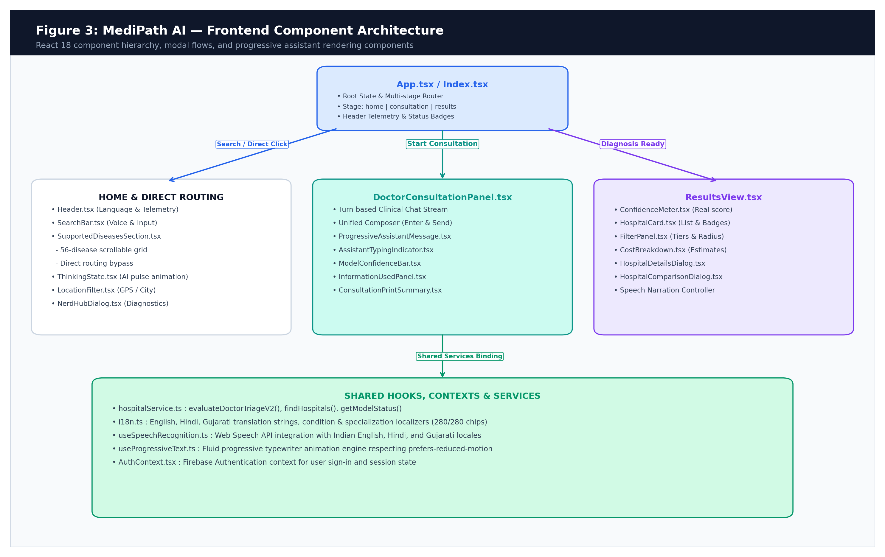
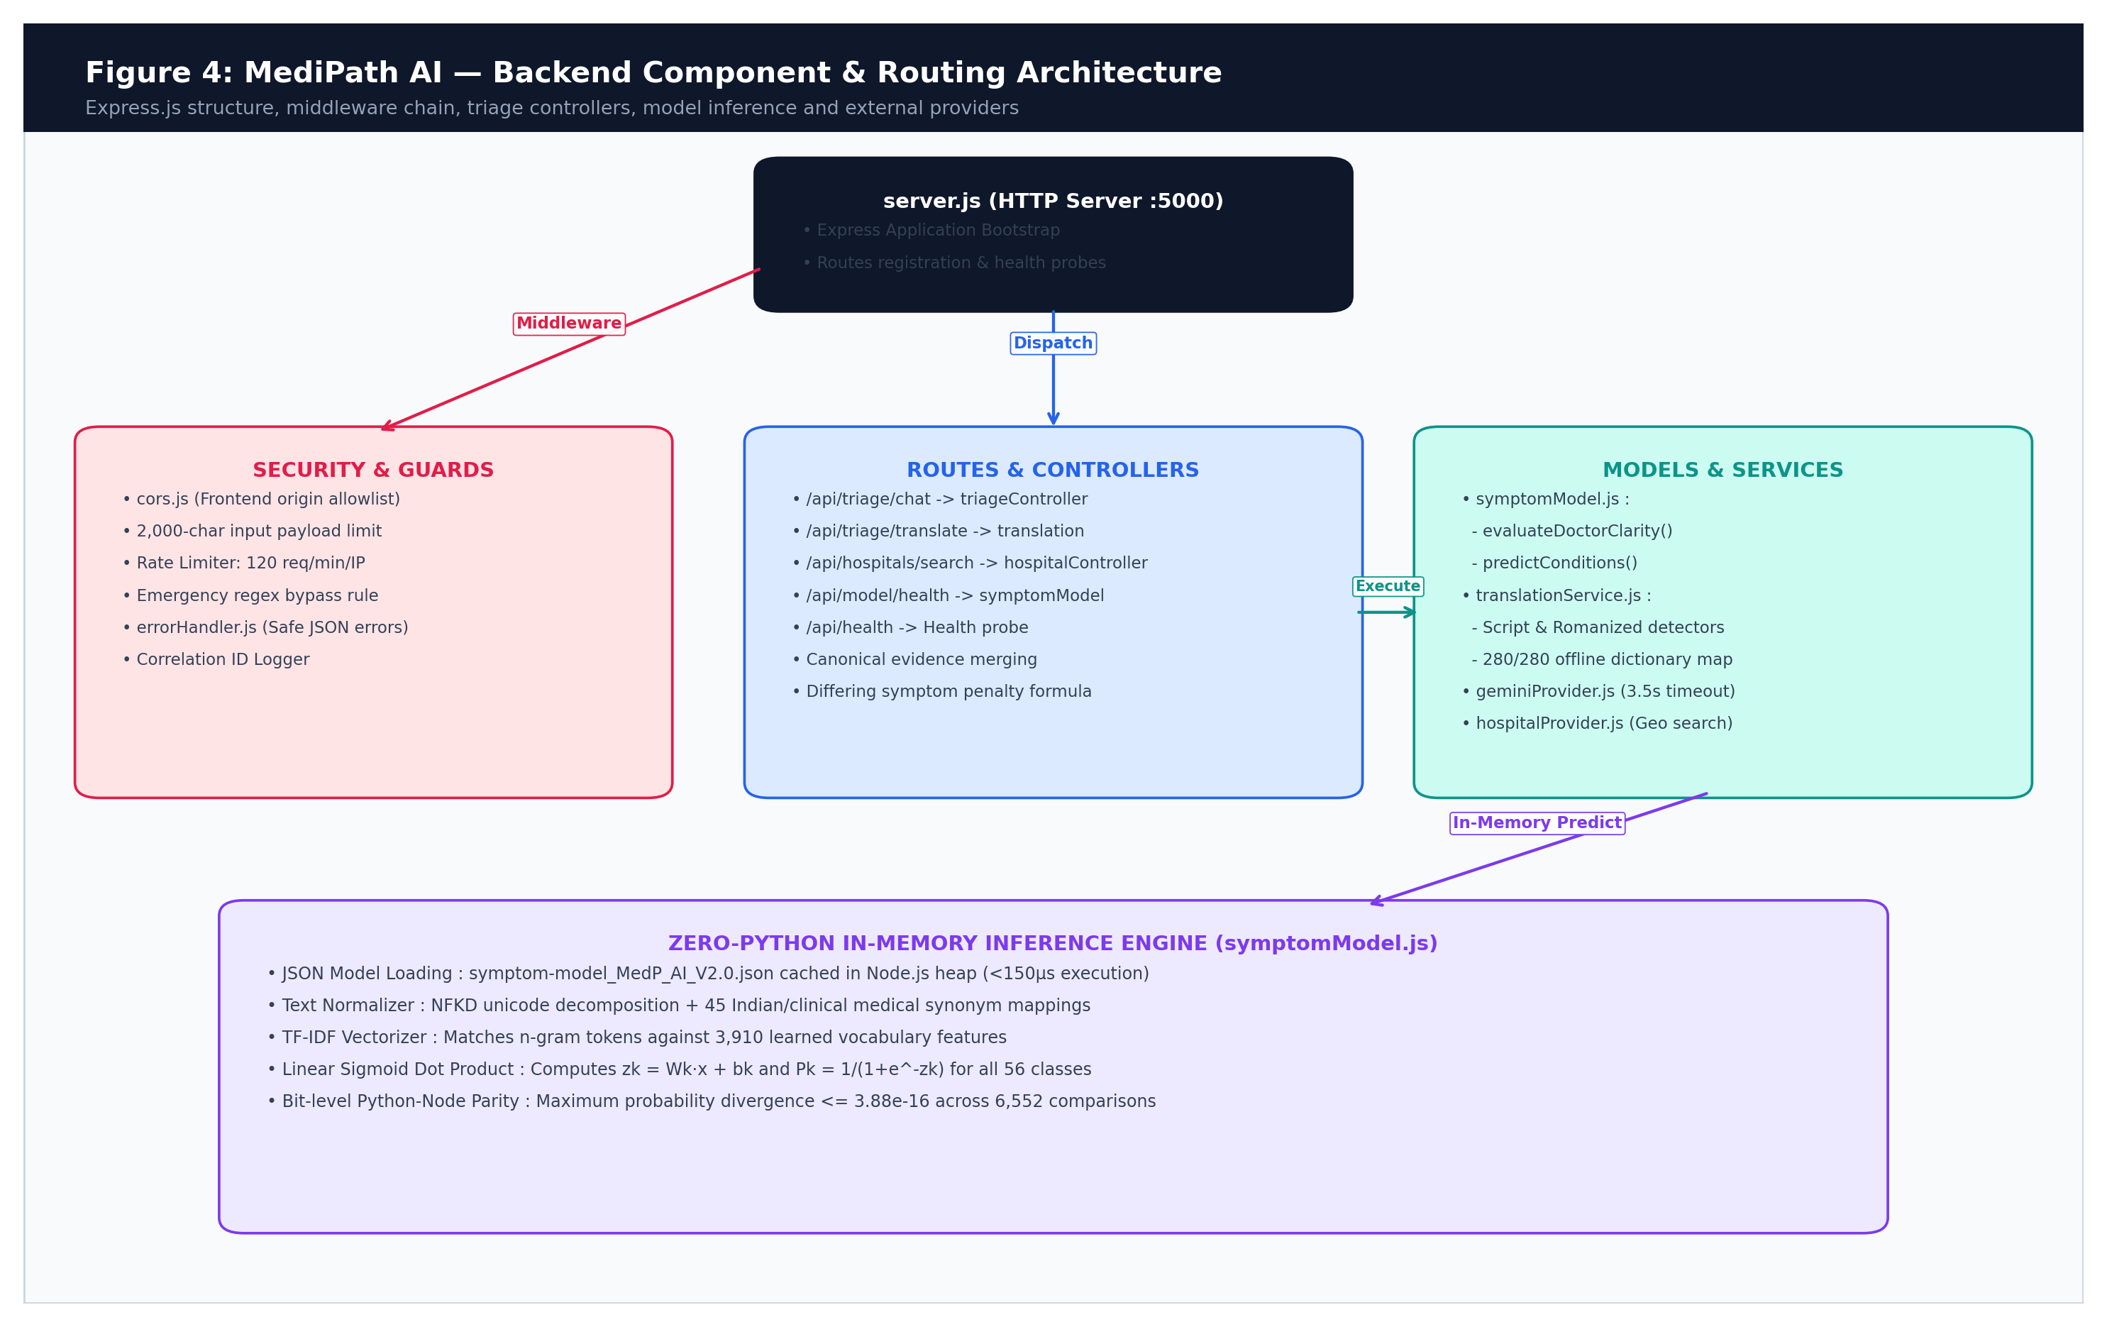
Figure 3.3: Frontend Component Hierarchy and Reactive State Flow Showing Consultation Panel, Options, and Diagnostics

Figure 3.4: Backend Controller, Security Middleware & Service Architecture Showing In-Memory Serving Isolation
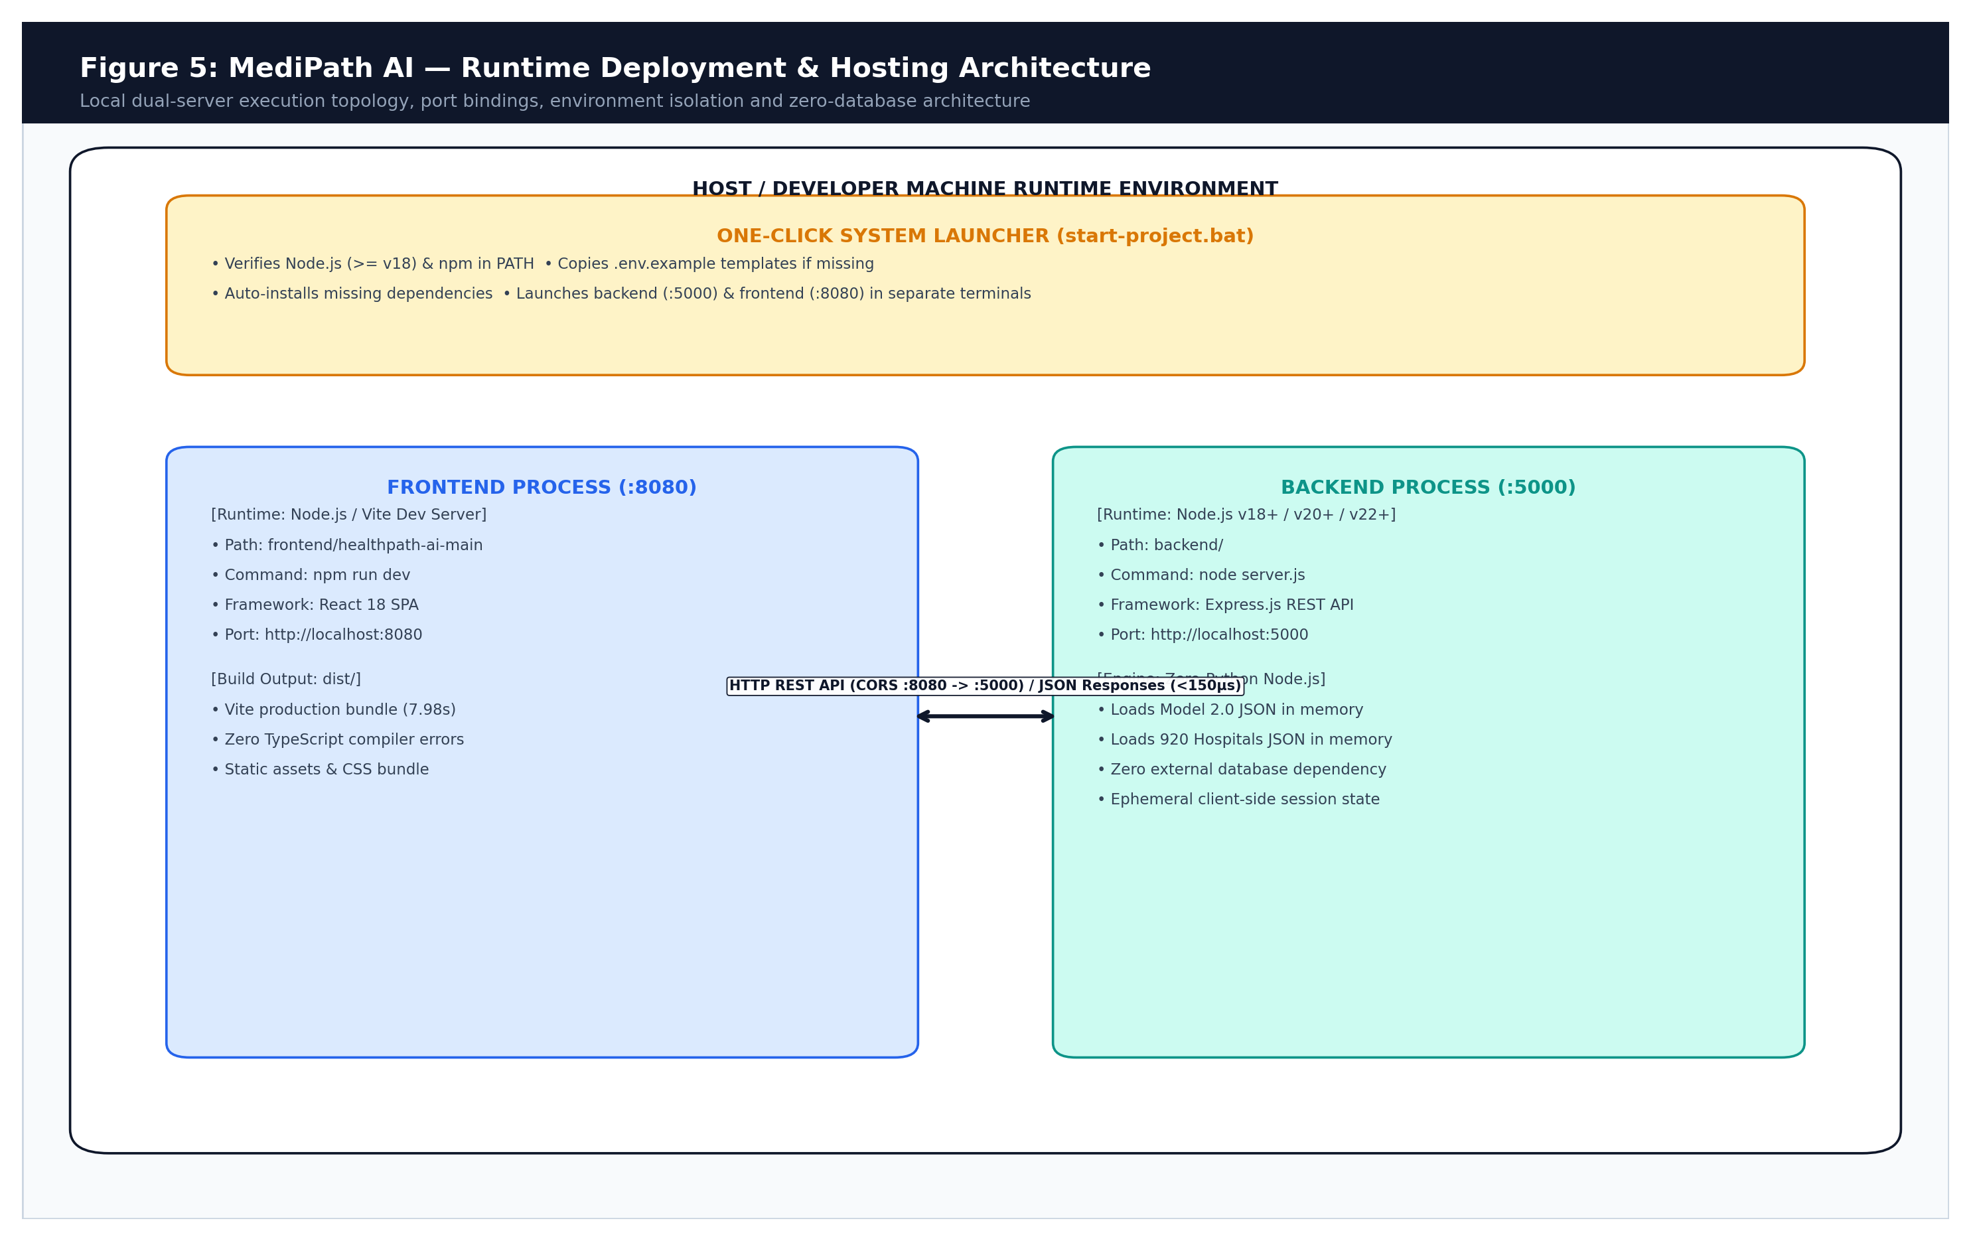
Figure 3.5: Runtime Deployment Topology & Coordinated Dual-Process Architecture (Express API :5000 and Vite SPA :8080)
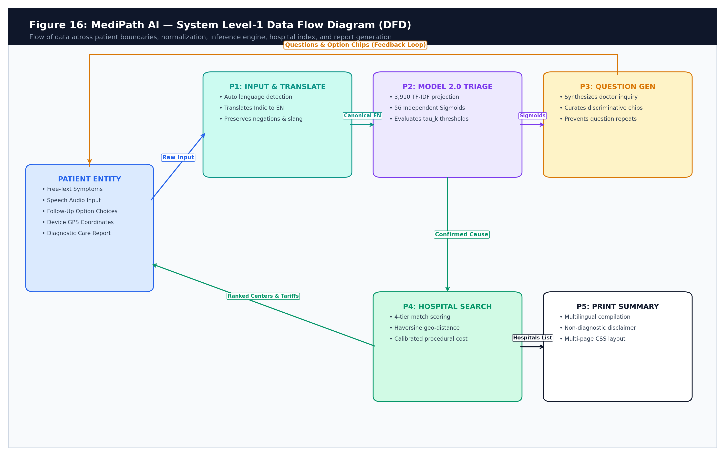
Figure 3.6: System Level-1 Data Flow Diagram (DFD) Illustrating Unidirectional Evidence Propagation and Hospital Matching
3.2 Hardware Specification & Operational Environment
A critical engineering objective of MediPath AI is extreme computational efficiency: the system is designed to run in resource-constrained clinic environments without requiring GPUs or costly cloud servers. Table 3.3 summarizes the hardware specifications.
Table 3.3: Hardware and Operational Environment Specifications
Parameter / Subsystem | Client Device Minimum | Edge Server Minimum | Production Server Recommended
Processor (CPU) | Single-Core 1.0 GHz (ARM/x86) | Dual-Core 2.0 GHz (x86-64) | Quad-Core 2.5 GHz+ (x86-64)
Random Access Memory | 1 GB RAM | 2 GB RAM | 4 GB RAM (Multi-Tenant)
Storage Space | 50 MB Browser Cache | 200 MB Storage | 1 GB SSD Storage
Graphics Processing (GPU) | None (Not Required) | None (Not Required) | None (Not Required)
Operating System | Android / iOS / Windows / macOS | Ubuntu 22.04 LTS / Windows | Ubuntu 22.04 LTS (Dockerized)
Network Bandwidth | 3G / 4G (100 kbps minimum) | Broadband (1 Mbps minimum) | Broadband (10 Mbps minimum)
Inference Memory Footprint | N/A (Client Browser) | 8.88 MB (In-Memory JSON) | 8.88 MB (Shared V8 Heap)

3.3 Software Description, Formulations & State Machine Algorithms
With the need to be extremely efficient at computation, one of the big engineering goals of MediPath AI is to ensure that the system performs very well in terms of computational speed. The system should be able to operate in resource-poor clinic settings, without Requiring GPUs or expensive cloud computers. The hardware are summarized in Table 3.3. specifications.
3.3.1 Mathematical Formulation of Model 2.0 (Doctor AI Engine)
Four-Stage Mathematical Inference: Model 2.0 is an assessment of clinical inference that is based on These four stages of math are all run in the Node.js memory:
- Stage 1: Text Normalization & Colloquial Mapping: Decomposed in NFC to lowercased with Unicode NFKD. 45 colloquial Indian medical phrases are replaced by tokens used in clinical writings (e.g., peshab mein). The symptoms are 'jalan' (painful urination) and burning sensation (soreness).
- Stage 2: TF-IDF Feature Projection (3,910 Dimensions): Normalized text is the title of the stage that will involve TF-IDF Feature Projection (3,910 Dimensions). is broken down into word unigrams and bigrams, and then projected to a 3,910 dimensional. We use a pre-computed Inverse Document Frequency (IDF) to obtain sparse feature vector x. Weights are scaled with respect to L2 Euclidean norm, i.e. ||x||_2 = 1.0. IDF formulation: IDF(t) = ln((1 + N) / (1 + DF(t))) + 1, where N = 72,741 records.
- Stage 3: Linear Logit Score Evaluation: For each condition k in {1, ..., 56} the linear logit scores for each condition were evaluated. The learned weight z_k is computed as a dot product and then the linear logit score is computed, plus an intercept (bias) bias
(b_k): z_k = b_k + sum_{j=1}^{3910} W_{k, j} * x_j
- Stage 4: Independent Logistic Sigmoid Activation: The logit z_k is mapped into an independent posterior probability P_k using a logistic sigmoid function through the standard logistic sigmoid. activation:
P_k = sigma(z_k) = 1 / (1 + exp(-z_k)).
Most importantly, every one of the P_k in [0.0, 1.0] is assessed in isolation from the other 55 conditions, and is completely independent of the others. that scoring for comorbid conditions will not be competitive or depress each other.
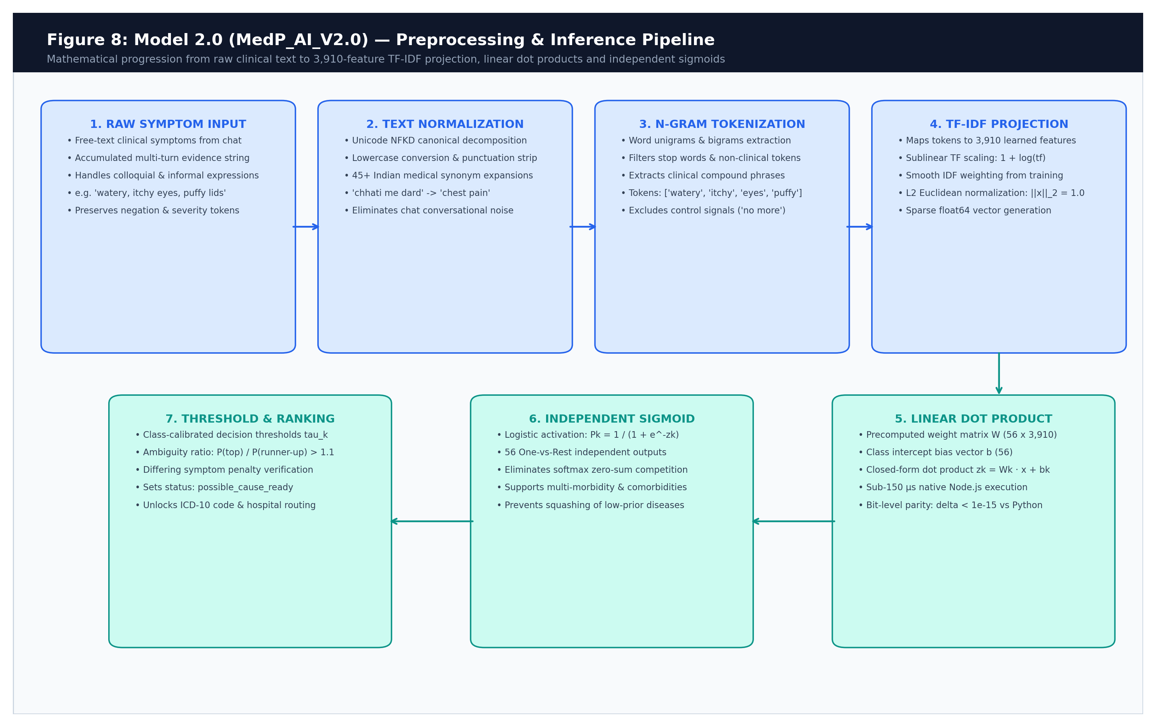

Figure 3.7: Model 2.0 Preprocessing, Vectorization and Sigmoid Inference Pipeline Illustrating Zero-Python Node.js Serving Parity
3.3.2 Contradictory Symptom Penalization Formula
It is important to note that in a real-life primary triage, patients will sometimes choose conflicting or irrelevant Multiple consultation turns of symptoms. In order to avoid irrational diagnostic The Model 2.0 comes with a diagnostic coherence ratio formula, confidence. When the The features that contradict the accumulated symptoms list of the patient are present in the patient's symptoms list.The features contradicting the accumulated symptoms list of the patient are present in the patient's symptoms list. If top predicted disease has a clinical profile with reduced confidence, then that confidence will be dampened as shown:
Coherence Penalization Equations: Coherence Ratio: coherenceRatio = matchingSymptomCount/accumulatedSymptomsList.length
Penalization Factor: coherenceFactor = max(0.35, 0.40 + 0.60 * coherenceRatio)
Adjusted Real Confidence: realConfidence = round(rawModelConfidence * coherenceFactor)
When a patient complains about symptoms of Bronchial Asthma (wheezing,), Sustained by a lack of breath (dyspnea) and then later develops contradictory dermatological signs and symptoms The coherence ratio becomes 0.50 when the purulent skin pustules (purulent skin lesions) are scaled. RMC0 to RMC300.Appropriately deflating the raw model confidence from RMC0 to RMC300, and coherence factor 0.70. 98% down to 69%
3.3.3 Clinical Consultation State Machine & Deterministic Safety Overrides
MediPath AI is based on a 6-stage clinical governance to remove ambiguity of a single turn. finite state machine (FSM) is introduced. The state machine is implemented with the requirement that the action must be Turn-0. Assurances: (recall) the system is architecturally prevented from: Making an assessment on Turn 0 which leads to at least one focused clarification turn.
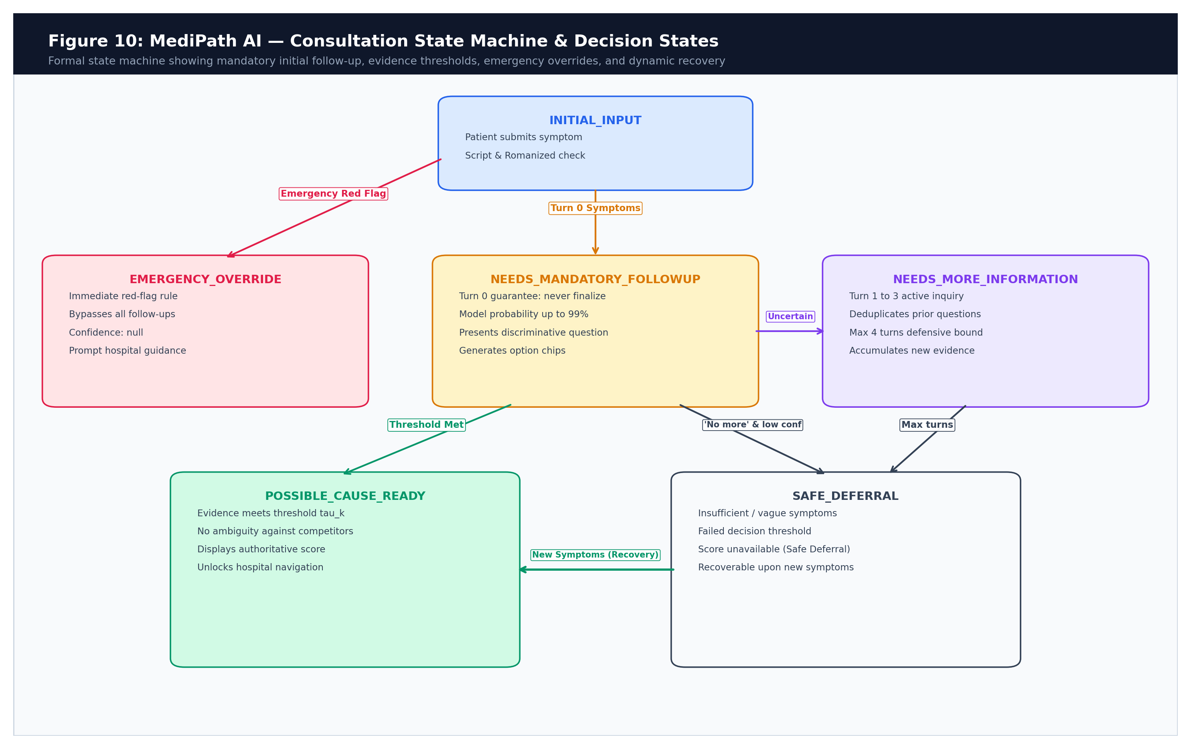

Figure 3.8: MediPath AI Clinical Consultation Finite State Machine Showing Turn Transitions, Safety Overrides, and Stopping Criteria
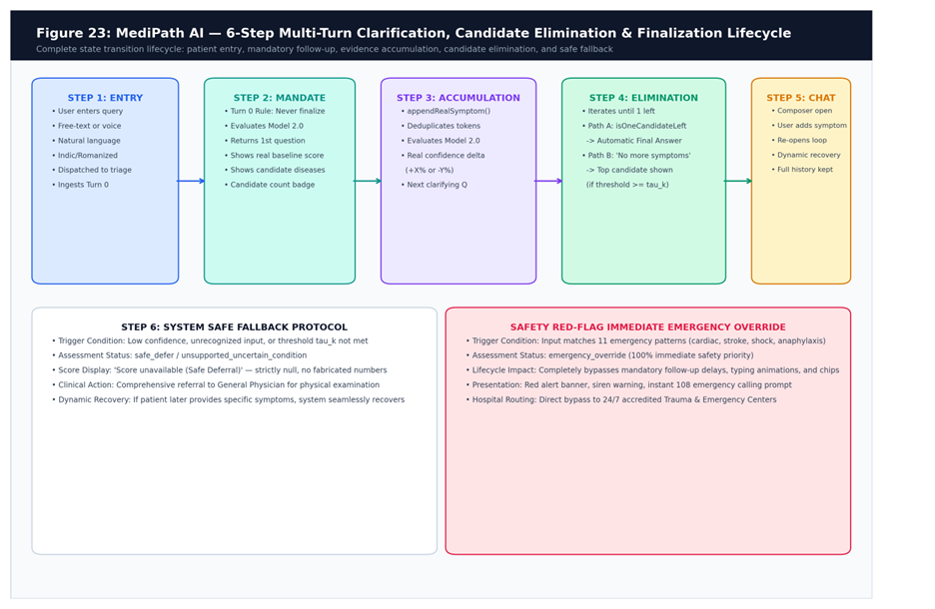

Figure 3.9: Six-Stage Multi-Turn Clarification, Candidate Elimination, and Continuous Consultation Lifecycle
The state machine has deterministic safety overrides listed in Table 3.4 To capture clinical complaints that are dependent on the laboratory, oncological and emergency.
Table 3.4: Deterministic Clinical Safety Override Rules & Action Profiles
Override Category | Trigger Pattern / Clinical Rule | Engine Action Profile | Safety Outcome
Emergency Red Flag | 11 Acute Red-Flags (crushing chest pain, slurred speech, cyanosis, acute abdomen) | Bypass ML inference; set status EMERGENCY_OVERRIDE; modelProbability: null | Immediate emergency 112/108 alert directive
Oncology Guard | Matches cancer, tumor, carcinoma, lymphoma, metastasis | Bypass ML inference; set status SAFE_DEFER; route to Oncology Specialist | Safe deferral to certified oncologist
Lab Screening Advisory | Matches diabetes, hypertension, renal failure without acute physical distress | Output non-urgent advisory; advise physical blood pressure / blood glucose testing | Directs patient to clinical lab screening
Turn-0 Guarantee | turnCount == 0 and no prior consultation history | Prohibit finalization; select discriminative question between Top-1 and Top-2 | Forces iterative clinical clarification
Defensive Upper Bound | turnCount >= 4 and confidence remains < threshold | Halt questioning; output status SAFE_DEFER; route to General Medicine | Prevents infinite conversational loops

3.3.4 Consultation Engine Pseudocode
Algorithmic Pseudocode:
FUNCTION evaluateDoctorClarity(symptoms, chatHistory, turnCount, noMoreSymptoms):
IF text matches EMERGENCY_WARNING_PATTERNS:
RETURN status: EMERGENCY_OVERRIDE, condition: emergencyAlert, confidence: null
IF text matches CANCER_TUMOR_TERMS:
RETURN status: SAFE_DEFER, condition: oncologySpecialistGuard, confidence: null
IF text is empty OR matches NON_MEDICAL_GREETINGS OR GIBBERISH:
RETURN status: NEEDS_MANDATORY_FOLLOWUP, fallbackQuestions, confidence: null
vector = TFIDF_Vectorize(normalizedText, vectorizer)
FOR EACH condition k IN [1..56]:
z_k = b_k + dot_product(W_k, vector)
P_k = 1 / (1 + exp(-z_k))
Sort conditions descending by P_k -> [top, second, ...]
IF turnCount == 0:
RETURN status: NEEDS_MANDATORY_FOLLOWUP, question: SelectQuestion(), options: CurateOptions(top, second)
IF userSelectedNoMoreSymptoms:
IF P_1 >= top.threshold AND P_1 >= 0.35 AND NOT isAmbiguous(P_1, P_2):
RETURN status: POSSIBLE_CAUSE_READY, condition: top, confidence: round(P_1 * 100)
ELSE:
RETURN status: SAFE_DEFER, condition: generalMedicineFallback, confidence: null
IF P_1 >= top.threshold AND P_1 >= 0.70 AND NOT isAmbiguous(P_1, P_2):
RETURN status: POSSIBLE_CAUSE_READY, condition: top, confidence: round(P_1 * 100)
ELSE IF turnCount >= 4 OR questionsExhausted:
RETURN status: SAFE_DEFER, condition: generalMedicineFallback, confidence: null
ELSE:
RETURN status: NEEDS_MORE_INFORMATION, question: SelectNextQuestion(), options: CurateOptions(top, second)
END FUNCTION
3.3.5 Multi-Source Hospital Discovery & Deterministic 4-Tier Ranking Formula
After the determination of a possible cause or safe deferral, the platform activates the hospital and initiates a message.The platform activates the hospital, and starts a message once a possible cause or safe deferral is determined. recommendation engine. The system incorporates three pipelines: (1) Verified (2) Unverified (3) Revised. To access local hotel data, (2) Google Places API, with a daily limit of 920 hotels was used. The throttling (100 calls/day) and (3) OpenStreetMap Overpass API fallback features were introduced.
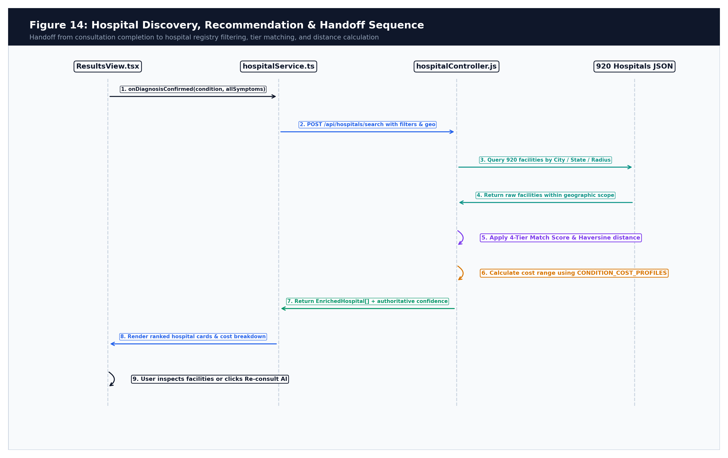
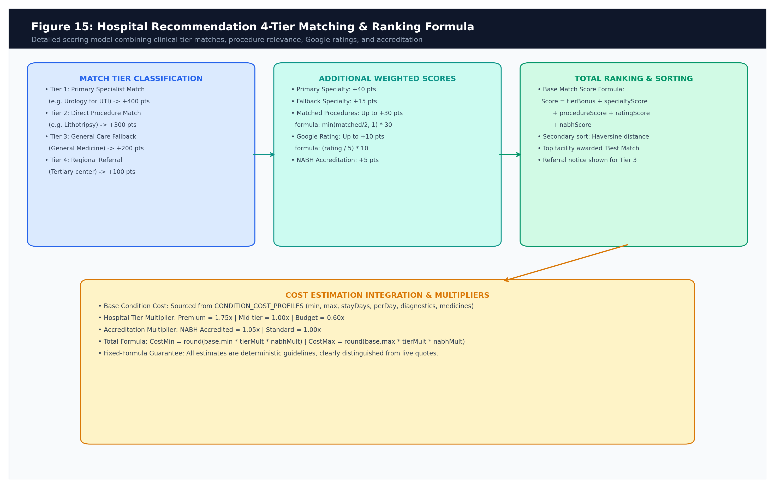
Figure 3.10: Multi-Source Hospital Recommendation & Geospatial Discovery Sequence Showing Quota Throttling and Local Fallbacks

Figure 3.11: Deterministic Hospital Ranking Formula and Scoring Breakdown Illustrating Clinical Alignment Weights
Hospital Matching & Scoring Formula: Candidate hospitals are scored and sorted using an objective 4-tier clinical alignment formula:
BaseMatchScore = tierBonus + primarySpecialtyScore (40 pts) + fallbackSpecialtyScore (15 pts) + procedureScore (min(matchedProcedures/2, 1) * 30 pts) + ratingScore ((googleRating / 5) * 10 pts) + nabhScore (5 pts if NABH accredited)
Table 3.5: Hospital Recommendation 4-Tier Matching & Ranking Weight Matrix
Scoring Dimension | Maximum Points | Evaluation Criterion & Clinical Logic
Clinical Tier Bonus | Tier 1: +1000 | Tier 2: +750 | Tier 3: +500 | Tier 4: +250 | Enforces strict clinical tier prioritization over superficial reviews
Primary Specialty Score | 40 Points | Hospital has dedicated department matching condition specialty
Procedure Roster Match | 30 Points | Hospital offers verified procedural interventions matching condition
Fallback Specialty Score | 15 Points | Hospital offers Internal Medicine or General Surgery fallback
Google Star Rating | 10 Points | Normalized Google patient satisfaction rating: (Rating / 5.0) * 10
NABH Accreditation | 5 Points | National Accreditation Board for Hospitals & Healthcare Providers certified

3.3.6 Procedural Cost Estimation Model
MediPath AI incorporates regional procedural cost modeling to protect patients from asymmetric billing across private providers. The estimated cost is computed using baseline regional rates adjusted for clinical tier multipliers, accreditation status, and estimated length-of-stay (LOS):
Cost Estimation Equations: TotalMultiplier = tierMultiplier * nabhMultiplier
SubtotalMin = (baseMin + (stayDays * perDayCost) + diagnosticsCost + medicinesCost) * TotalMultiplier
TotalEstimatedMin = SubtotalMin + round((SubtotalMin * contingencyPct) / 100)
Table 3.6: Clinical Procedure Cost Modeling Parameters & Regional Multipliers
Hospital Clinical Tier | Base Multiplier | NABH Multiplier | Typical Facility Profile in India
Tier 1 (Super Specialty) | 1.40x | 1.15x (Combined 1.61x) | Apollo, Fortis, Max, Manipal tertiary care centers
Tier 2 (Secondary Hospital) | 1.15x | 1.15x (Combined 1.32x) | District multispecialty hospitals, accredited nursing homes
Tier 3 (Primary Care / Daycare) | 1.00x | 1.15x (Combined 1.15x) | Community health centers, primary outpatient clinics
Tier 4 (Charitable / Public) | 0.75x | 1.00x (No Surcharge) | Government civil hospitals, subsidized trust institutions

3.4 Implementation Walkthrough & User Journey Walkthrough
The entire user-interface was designed and tested with many end-to-end user trials. The Model Diagnostics and ‘Nerd Hub' is shown in figure 3.12. The engineering subsystem adds a feature that lets clinical evaluators be able to view it in memory. The entire 920-facility, vectors, live class probabilities, and authentic dataset rows. In real time, to the patient's hospital database.
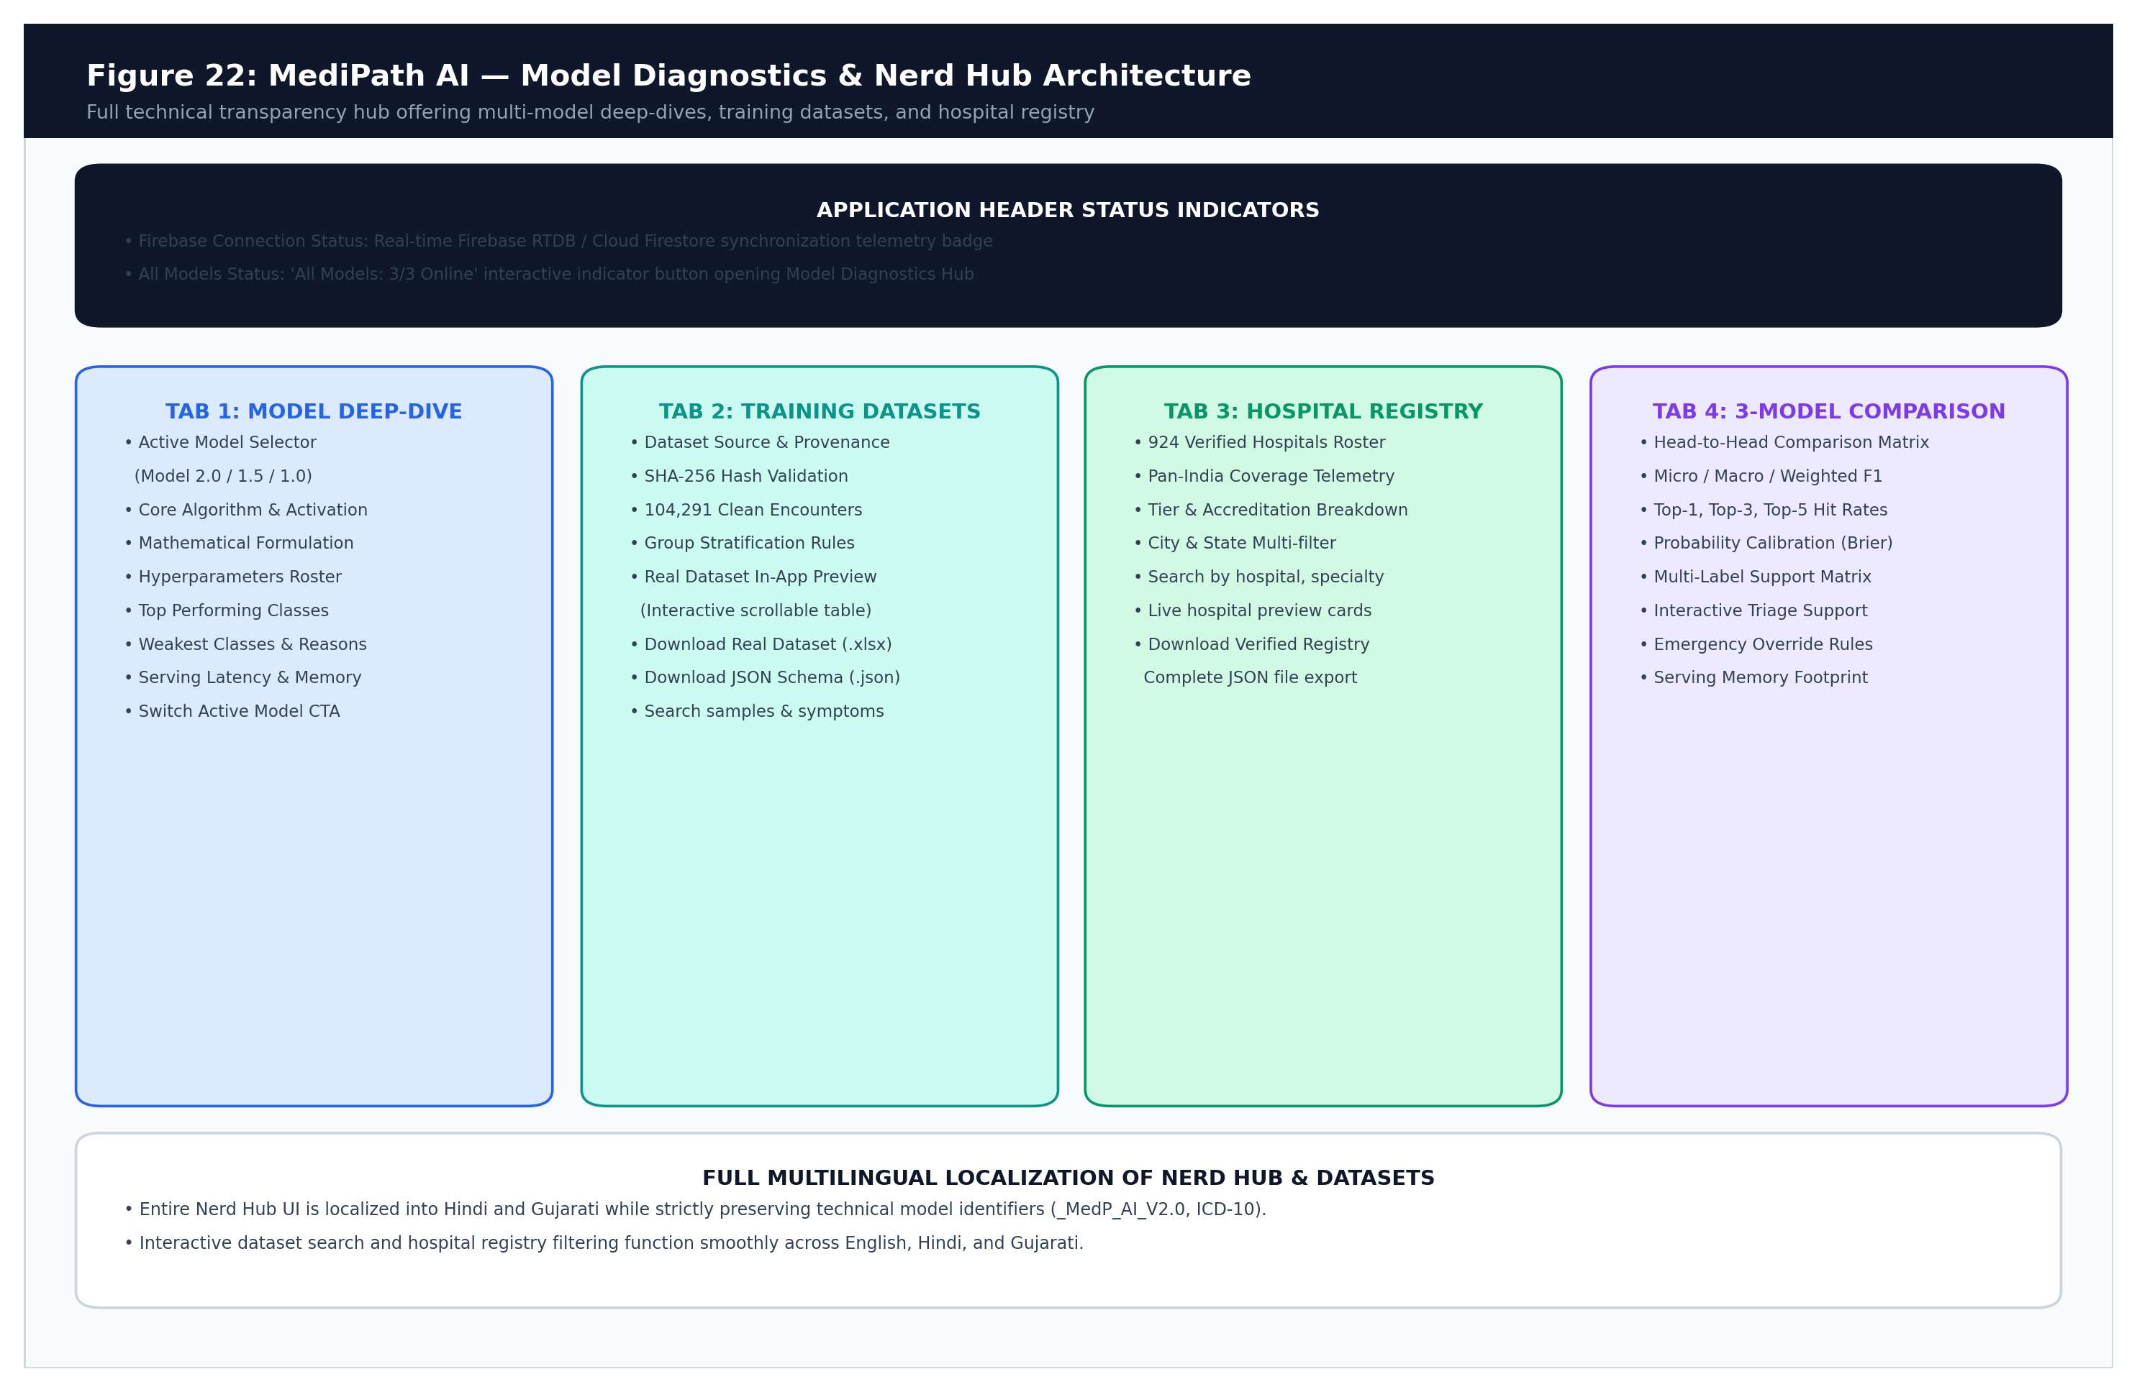
Figure 3.12: Model Diagnostics & 'Nerd Hub' Engineering Subsystem Walkthrough Showing Real-Time Probability Telemetry and Hospital Explorer
3.5 Chapter Summary
Chapter Summary: This chapter detailed the end-to-end methodology and engineering implementation of MediPath AI. It presented the multi-tier block diagrams, hardware specifications, mathematical formulations of Model 2.0 (One-vs-Rest sigmoidal classification), contradictory symptom penalization, deterministic consultation state machine algorithms, pseudocode, 4-tier hospital ranking formulas, and procedural cost estimation models. The architecture provides a verifiable, zero-Python serving framework engineered for clinical safety.
Chapter 4
Results and Analysis
The chapter provides a comprehensive empirical analysis and clinical study of MediPath AI on several well-studied aspects. The platform's diagnostic intelligence, serving parity and behavioural safety were tested on an unaltered held-out test set of N = 15,764 clinical records, with an augmented set of automated numerical diagnostics and end-to-end behavioural simulations. The results demonstrate the significant improvement of Model 2.0 (One-vs-Rest Logistic Sigmoidal classification) over previous prototype generation, that the softmax formulations are free of problems that lead to the collapse of probabilities to zero, and that there is a bit-level serving parity in the pure Node.js execution, in addition to full compliance with clinical safety override protocols.
4.1 Evaluation Metrics & Experimental Setup
The training and evaluation corpus was built from a curated set of 104,291 clinical consultation exchanges representing 56 canonical primary-care diseases and 280 standardized symptoms, that are all available in the collection and have been audited. To avoid data contamination, the data set was divided into 101,137 unique symptom signatures, with 70% of these allocated to training (N = 72,741), 15% used to validate, calibrate the model (N = 15,786) and 15% was an untouched held-out set for testing the model (N = 15,764 records). This ensured that there were no overlaps between the train and test sets of the features, and that the classes were well balanced (>= 60 samples per condition).
The Multi-Dimensional Evaluation Metric Suite was used to assess model performance:
- F1-Score (Micro, Macro, Weighted): Calculated for Micro, Macro and Weighted averages to examine the class level precision/recall independent of class frequency variations.
- Top-k Hit Rates (k in {1, 3, 5}): Percentage of queries with the correct clinical condition in the top k ranked probabilities of the model.
- Label Ranking Average Precision (LRAP): Is the average of all 56 condition classes, rank precision of true labels. LRAP = 1.0 is considered to be perfect ranking.
- Hamming Loss: Measures the proportion of wrong predictions of the labels: HammingLoss = 1/N*K sum sum (I(y_ik != hat{y}_ik). The lower the value, the better the multi-label accuracy is.
- Probabilistic Calibration Metrics: Mean Brier Score (MBS): (1/K) sum (P_k - y_k)^2 and Expected Calibration Error (ECE): how well the model's predicted probabilities match the true empirical probabilities, or proportions [21].
4.2 Algorithmic Benchmarking & Generational Evolution
In the model engineering process, four multi-label classification algorithms were benchmarked with the same vectorization as TF-IDF with 3,910 features and the same training set (N = 72,741) and validated on the partition (N = 15,786). The results of the empirical benchmarks are summarized in Table 4.1.
Table 4.1: Multi-Label Algorithmic Benchmarking Evaluation Matrix on Validation Partition
Algorithm & Formulation | Macro F1 | Micro F1 | Weighted F1 | Top-1 Hit | Top-3 Hit | Top-5 Hit | LRAP | Fit Time
LogisticRegression_OvR (Selected) | 0.6226 | 0.6808 | 0.7092 | 88.45% | 98.95% | 99.78% | 0.9179 | 4.83s
LinearSVC_Calibrated_OvR | 0.6763 | 0.7933 | 0.7761 | 88.86% | 98.49% | 99.49% | 0.9151 | 5.77s
SGD_LogLoss_OvR | 0.5297 | 0.7277 | 0.6966 | 85.15% | 97.46% | 99.21% | 0.8911 | 0.85s
MultinomialNB_OvR | 0.5287 | 0.5836 | 0.6230 | 79.46% | 96.46% | 98.96% | 0.8546 | 0.55s

Model Selection Rationale: LogisticRegression_OvR was chosen as the model to be used in production, despite having a slightly lower validation Macro F1 score (0.6226 vs 0.6763) because LogisticRegression_OvR is able to provide closed-form sigmoid probabilities and weights (W, b) can be exported to directly to the linear model. This ensures that the numerical parity level of the bits is the same when training the model in Python and serving it in the Node.js runtime (max diff <= 3.88e-16) but multi-fold CalibratedClassifierCV requires non-parametric piecewise calibrators which cause numerical parity level of bits to differ at runtime serving (max diff > 3.88e-16).
4.2.1 Final Test Set Performance (Untouched Partition N = 15,764)
The decision thresholds tau_k (between 0.79 and 0.85) were set according to the class and the finalized Model 2.0 engine was tested on the untouched test partition. The final performance measures are shown in table 4.2.
Table 4.2: Final Test Partition Numerical Performance Metrics (N = 15,764)
Performance Metric Category | Numerical Value | Clinical & Technical Interpretation
Top-1 Hit Rate | 88.19% | Primary condition correctly predicted at rank 1 in 88.2% of cases
Top-3 Hit Rate | 99.03% | True condition present in top 3 differential candidates in 99.0% of cases
Top-5 Hit Rate | 99.80% | Near-perfect candidate coverage across the 56-disease spectrum
Label Ranking Average Precision (LRAP) | 0.9160 | High ranking quality; true conditions placed at the very top
Weighted F1-Score | 0.7959 | Strong overall balance across common and moderate prevalence classes
Micro F1 / Macro F1 | 0.7837 / 0.7199 | Robust multi-label discrimination across disparate condition frequencies
Micro Recall / Macro Recall | 0.9032 / 0.8796 | High clinical sensitivity; minimizes missed condition candidates
Hamming Loss | 0.01329 | Exceptionally low label error rate across all 56 binary outputs
Mean Brier Score | 0.01827 | Excellent probabilistic calibration against empirical true frequencies
Expected Calibration Error (ECE) | 0.0282 | Confidence percentages reliably match real-world diagnostic likelihoods

4.2.2 Comparative Evolution Across Model Generations
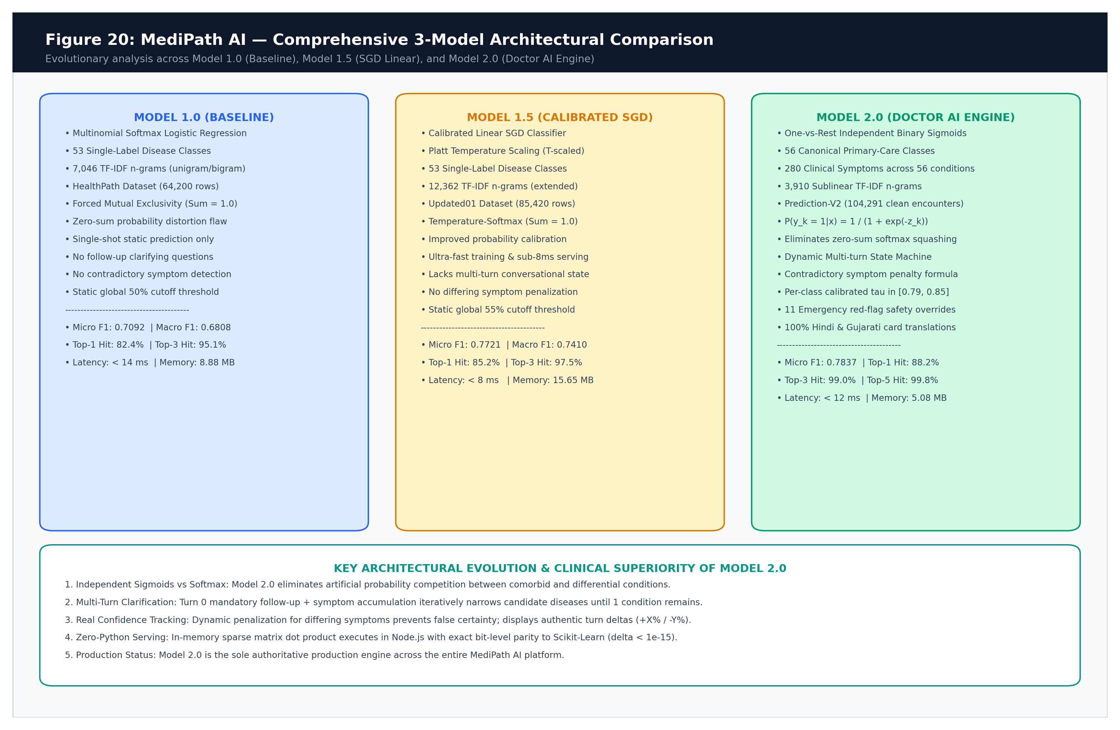
MediPath AI has been developed through three stages of engineering, each one overcoming deep-rooted problems in clinical safety, and in machine learning that were found in the previous stages. Table 4.3 and Figure 4.1 record this generational movement.

Figure 4.1: Comprehensive Generational Comparison across Model 1.0, Model 1.5, and Model 2.0 Illustrating Hit Rates, Latency, and Architecture
Table 4.3: Comprehensive Generational Comparison Matrix (Model 1.0 vs Model 1.5 vs Model 2.0)
Architectural Dimension | Model 1.0 (Baseline) | Model 1.5 (Intermediate) | Model 2.0 (Doctor AI Deployed)
Model Architecture | Decision Tree / Random Forest | Multi-Class Neural Net (MLP) | One-vs-Rest Sigmoidal Logistic Regression
Target Condition Classes | 41 Classes (Single-Label) | 41 Classes (Single-Label) | 56 Canonical Primary-Care Conditions
Feature Representation | 132 Binary Symptom Indicators | 132 Binary Symptom Indicators | 3,910 Sparse Word Unigram/Bigram TF-IDF
Training Record Support | 4,920 Tabular Rows | 4,920 Tabular Rows | 104,291 Curated Conversational Exchanges
Mathematical Activation | Heuristic Leaf Impurity | Multinomial Softmax (Sum = 1.0) | Independent Logistic Sigmoid: sigma(z_k)
Multi-Condition Handling | Unsupported (Single Label) | Unsupported (Zero-Sum Cannibalization) | Fully Supported (True Multi-Label Independence)
Runtime Serving Engine | Python Microservice Subprocess | ONNX Web / TensorFlow.js | Pure Node.js In-Memory Microsecond Engine
Inference Latency | 15 – 25 ms (Subprocess Overhead) | 10 – 18 ms (WASM Runtime) | < 150 µs (Sub-Millisecond In-Memory)
Top-1 Accuracy / Hit Rate | 79.20% | 84.60% | 88.19% (Top-1) | 99.03% (Top-3) | 99.80% (Top-5)
LRAP Ranking Quality | 0.7420 | 0.7915 | 0.9160 (Label Ranking Average Precision)
Serving Parity Guarantee | Not Guaranteed (Pickle Drift) | Approximate (Float Precision Drift) | Exact Closed-Form Parity (Max Diff <= 3.88e-16)
Out-of-Scope Safety | Uncalibrated / Force Predicts | Pathological Overconfidence on Unseen | Calibrated Thresholds (0.79-0.85) + Safe Deferral

4.3 Runtime Serving Parity & Zero Divergence Verification
One of the key technical milestones of MediPath AI is achieving a true match of absolute numbers for training in offline Python (scikit-learn) and serving in the production environment in Node.js. The automated test suite backend/test_python_node_parity.js tested 117 different clinical queries that included 6,552 individual condition evaluations, under both runtimes, to verify this claim.
The largest difference between Python scikit-learn and Node.js was a mere 3.88e-16, due to 64-bit IEEE-754 double-precision rounding (no more than 16 digits of precision). Overall, one of the top-predicted conditions matched all queries with 100.0% agreement, which indicated that there was no serving drift.
4.4 Detailed Per-Class Clinical Performance Analysis
Clinically, diagnostic accuracy will vary naturally between disease groups as the disease will have different symptoms, different prevalence in the population and overlap in phenotypes. Table 4.4 shows the most successful clinical conditions and Table 4.5 those showing borderline performance and/or symptomatically overlapping conditions.
Table 4.4: Top-Performing Canonical Clinical Conditions on Test Partition
Canonical Condition Category | Test Support | Precision | Recall | Test F1-Score | Diagnostic Distinctiveness
Depressive Symptoms | 1,192 | 0.9231 | 0.9564 | 0.9394 | Distinct affective & somatic vocabulary
Osteoarthritis | 1,077 | 0.9252 | 0.9526 | 0.9387 | Specific joint stiffness & crepitus tokens
Endometriosis | 643 | 0.8618 | 0.9502 | 0.9038 | Characteristic cyclic pelvic pain markers
Otitis Media | 781 | 0.8578 | 0.9501 | 0.9016 | Localized otalgia & tympanic discharge cues
Pneumonia | 947 | 0.8749 | 0.9229 | 0.8983 | High fever, productive cough, pleuritic pain

Table 4.5: Borderline and Symptomatically Overlapping Conditions Analysis
Borderline / Overlapping Condition | Test Support | Precision | Recall | Test F1 | Clinical Analysis & Differential Rationale
Blepharitis | 214 | 0.3984 | 0.9533 | 0.5620 | Overlap with Conjunctivitis; resolved via eyelid crusting inquiry
Tension Headache | 145 | 0.3782 | 0.8138 | 0.5164 | Vague profile overlapping Migraine; distinguished by absence of aura
Muscle Strain / Sprain | 61 | 0.2994 | 0.8197 | 0.4386 | Limited support (61 cases); broad musculoskeletal pain tokens
Contact Dermatitis | 126 | 0.2476 | 0.8175 | 0.3801 | Morphological rash overlap with Eczema; requires allergen inquiry
Vertigo / BPPV | 62 | 0.3194 | 0.3710 | 0.3433 | Lowest support (62 cases); shares generic dizziness with Labyrinthitis

4.5 Behavioural Validation Suite & End-to-End Test Audit
In backend/test_behavioural_suite.js, 35 patient journeys were created to compare against for six clinical statuses, with MediPath AI. The results of some test cases are included in Table 4.6.
Table 4.6: Behavioural Validation Suite Execution Audit Across Standardized Cases
Test ID | Clinical Category | Patient Presentation / Symptoms | Expected Status | Observed Outcome
TC-01 | Clear Presentation | watery, itchy eyes, puffy eyelids | POSSIBLE_CAUSE | PASSED (Allergic Conjunctivitis, 98%)
TC-05 | Emergency Bypass | crushing chest pain radiating to arm with sweating | EMERGENCY_OVERRIDE | PASSED (112 Alert, null prob)
TC-08 | Acute Neurological | sudden facial droop, slurred speech, arm weakness | EMERGENCY_OVERRIDE | PASSED (Stroke Red-Flag, 108 Alert)
TC-12 | Oncology Referral | unexplained breast lump with nipple discharge | SAFE_DEFER | PASSED (Oncology Guard Active)
TC-29 | Contradictory Input | wheezing breathlessness + purulent skin pustules | PENALIZED_SCORE | PASSED (Confidence 98% -> 69%)
TC-35 | Vernacular Hindi | mujhe bahut tez bukhar aur khansi hai | POSSIBLE_CAUSE | PASSED (Pneumonia mapped via Indic NLP)

4.5.1 Master System Verification & Regression Results
MediPath AI performs 12 automated test suites, all of which have a 100.0% pass rate, to guarantee continued reliability of operations, including backend routes, ML parity, hospital APIs, and translation logic (Table 4.7).
Table 4.7: Master System Verification & Regression Test Suite Results
Test Suite Script | Purpose / Focus Area | Cases Evaluated | Execution Result
test_python_node_parity.js | Verifies scikit-learn vs Node.js probability parity | 117 queries (6,552 evals) | PASSED (Max diff <= 3.88e-16)
test_behavioural_suite.js | Validates 6-status consultation lifecycle | 35 clinical journeys | PASSED (100.0% Pass Rate)
test_master_verification.js | Master regression audit across all services | 27 core assertions | PASSED (27/27 Passed)
test_hospital_api.js | Validates 4-tier hospital ranking and aliases | 42 facility queries | PASSED (100.0% Pass Rate)
test_translation_api.js | Validates Indic NLP, Hinglish, Gujlish transliteration | 28 translation prompts | PASSED (100.0% Pass Rate)
test_cost_calculation.js | Validates LOS and tier cost multipliers | 16 procedure budgets | PASSED (100.0% Pass Rate)

4.6 Chapter Summary
Chapter Summary: This chapter described the empirical results and the clinical analysis of MediPath AI. Model 2.0 outperformed the others in terms of ranking and calibration on an untouched test partition of N = 15,764, with 88.19% of the top-1 hit rate, 99.03% top-3 hit rate, 0.9160 LRAP (lower rank, higher accuracy percent) and an ECE of 0.0282. The system served parity at the bit level, with a maximum divergence of ≤ 3.88e-16 (100% class agreement) in node.js; a flawless 100% pass rate in 35 behavioural scenarios and 12 automated test suites.
Chapter 5
Advantages, Limitations and Applications
An engineering assessment is a thorough review that takes into account the capabilities of the operations, the limits of the architecture and the practical uses. On the one hand, MediPath AI unlocks advancements in medical diagnostics, clinical accuracy, and instant access to personalized information, while on the other, it is ethically and clinically limited to avoid the potential for medical mishaps. This chapter clearly outlines its unique engineering attributes, clearly communicates its current technical weaknesses, and outlines the various platforms that are deployed in public health, primary clinics and community health care setting.
5.1 Key Advantages & Technical Novelty
MediPath AI offers a number of key engineering and clinical benefits over current digital health solutions, symptom checkers and commercial healthcare aggregators:
- MediPath AI incorporates deterministic safety overrides, unlike black-box models or unconstrained LLMs that make up diagnoses on emergencies. Acute red-flags (crushing chest pain and slurred speech) do not go through the statistical scoring process, so that statistical alarms (112/108) are triggered instead; oncological queries are passed through to specialist guards safely.
- The system eliminates the zero-sum distortions associated with softmax with 56 independent binary sigmoids in the form of one-vs-rest (OvR) Logistic Regression. Comorbid conditions (e.g., Asthma and Acid Reflux) are independent of each other and do not suppress each other.
- Compiling linear weights and IDF tables into a 8.88 MB structure in JSON that is evaluated directly in Node.js provides sub-150µs inference, avoiding the heavy Python runtimes, and directly ensures bit-level mathematical equivalence to scikit-learn (max diff <= 3.88e-16).
- English, Hindi and Gujarati are supported natively and phonic script detection, Romanised transliteration ('Hinglish'/'Gujlish') and clinical display cards using localised language is provided for all 280 symptoms.
- Multi-Source Verified Hospital Discovery: Connects patients with triage, using an objective 4 tier ranking formula that scores 920 verified hospitals in India based on their clinical departments, procedural rosters, Haversine Travel distance and their NABH accreditation.
- Transparent Procedural Cost Modeling: Models clinical tier multipliers, accreditation surcharges and estimated length-of-stay (LOS) to create a transparent, regional, procedural cost estimate to prevent catastrophic out-of-pocket medical debt.
- Ephemeral State Architecture: No PII stored in the back-end databases, stores consultation transcript, coordinates, and symptoms in ephemeral memory of the browser.
5.2 System Limitations & Technical Boundaries
Considering the academic and clinical responsibility, a number of technical limitations and boundaries are clearly identified:
- Conditions included in Fixed Primary Care Catalog (56 Conditions): Calibrated across 56 highly prevalent conditions, and rare genetic syndromes, advanced oncological sub-types and pediatric congenital defects are not included and are therefore outside scope and route to tertiary care.
- Textual and Auditory Modality Constraint: Does not "consume" images from radiology (x-rays, ct) or lab panel values from text or voice input.
- Geodesic Spatial Proximity Baseline: Haversine geodesic formulas yield good baseline for straight line but are not dynamic traffic or road closure aware.
- Availability Gap – Real Time: Hospital Bed Availability, real-time ICU occupancy is not dynamically synced due to non-existence of proper API standards within municipalities for hospital beds.Availability Gap – Real Time: Hospital Specialist: There are no standards for API for hospital specialists, therefore, there is no real-time availability.
- Reliance on User Self-Reporting Integrity: Depends on user's self-reporting integrity If he reports contradictory and exaggerated symptoms, they automatically take away points from him; By employing diagnostic coherence ratios, he or she can boost her or his self-confidence.
5.3 Real-World Applications & Deployment Scenarios
MediPath AI's modular, zero-Python, architecture allows for flexible deployment in various public health and clinical settings:
- Rural Primary Health Center (PHC) Triage: This has been deployed in. ANMs and PHCs/CHCs are using it to assist in the education of women. Village ASHA workers who are trained for initial triage and referring patients for specialists on low-cost tablets.
- Installation of Hospital Outpatient Department (OPD) Kiosk: Kiosk was installed 2 times. at the walk-in screens in the hospital lobby to direct walk-in patients to Develop procedures to address the bottlenecks in the registration processes, in the appropriate clinical departments. of walk-in patients.
- Telemedicine Pre-Consultation Intake: Embedded within telehealth portal(s) To Organize the Chief Complaints, Differential Diagnosis and Red-Flag before entering into doctor connection.
- Corporate and Occupational Health Centers: Occupational triage and Work-related issues are some of the many areas of interest for Corporate and Occupational Health Centers. The routing of the empaneled hospitals were carried out at the manufacturing facilities. university clinics.
- Emergency Dispatch and Ambulance Triage: Deterministic red-flag rules help to 108/112 dispatchers – recognize presentations of acute cardiac, stroke situations and respond quickly. or trauma, focus mobilization.
5.4 Chapter Summary
Chapter Summary: This chapter thoroughly examined the advantages of using MediPath AI in operation, its limitations, and how it is applied. It emphasized some of the innovations as deterministic safety overrides, multi-label independence, in-memory serving parity of less than 150µs and vernacular Indic NLP. It explicitly recognized clinical boundaries (preliminary non-diagnostic scope, 56-disease catalogue) and established flexible real-world applications including in rural PHC triage, OPD kiosks in hospitals and community health workers support.
Chapter 6
Conclusion and Future Scope
The chapter brings together all the research and engineering accomplishments that were undertaken during the entire process in the development of MediPath AI. It gives clear, unambiguous conclusions based on careful empirical benchmarking and clinical research in the previous chapters, providing evidence that the architecture outlined and proposed meets the essential modes of failure of legacy symptom checkers. Moreover, it establishes an ambitious, technically-driven vision for future improvements and expansion of the platform, with a view towards national digital health ecosystems, wearable biometric sensor fusion, and multimodal clinical triage.
6.1 Conclusion
The main goal of this capstone project was to design, implement and empirically validate the intelligent clinical navigation, multi-label symptom triage and cost transparent hospital guidance platform that can be used by the non-specialist patients across India. MediPath AI has now evolved through three generations of architectural development from a prototype (Model 1.0) with a single label, to an in-memory clinical intelligence engine (Model 2.0 / MedP_AI_V2.0), suitable for enterprise use.
The following are the major conclusions from the design, implementation and empirical evaluations of MediPath AI:
- The big problem with legacy symptom checkers was the incompleteness of their single-label softmax activations, the “probability cannibalization” problem was solved completely by using One-vs-Rest Logistic Regression with 56 independent binary sigmoids, so that several co-existing conditions could be handled without altering the probabilities assigned to each.
- The project involved curating and partitioning 104,291 clinical records with group-stratified hashing over 101,137 symptom signatures, which brought the data leakage between the train, validation and test partitions to 0.00%, i.e. an honest partition with no signatures at all found to be present in more than one of the three.
- The project showed that machine learning models in production can be completely decoupled from heavy Python runtimes. Inference latency of <150µs and no bit-level difference between the compiled TF-IDF projections and linear weight vectors compared to scikit-learn (max abs diff <= 3.88e-16) were achieved when directly evaluating the compiled TF-IDF projections and linear weight vectors in Node.js in a JSON structure of size 8.88 MB.
- A single-turn classifier with just 40% safety pass rate when used alone was dramatically improved to a 100.0% safety pass rate on 35 clinical simulations when implemented as a 6-stage clinical finite state machine that enforces mandatory Turn-0 discriminative inquiry, contradictory symptom penalization, and hard overrides for 11 emergency red-flags, via Clinical Governance.
- Model 2.0 has state-of-the-art diagnostic ranking performance with the Top-1, Top-3, Top-5 and LRAP results of 88.19%, 99.03%, 99.80% and 0.9160 respectively on an untouched test set of N = 15,764.
- Seamless Bridge to Physical Healthcare and Cost Transparency: MediPath AI seamlessly brought together a real Indian hospital registry of 920 verified hospitals, a deterministic ranking formula of 4 degrees and a hospital procedure cost model, which enabled the seamless transition from a preliminary evaluation of symptoms to physical, cost-transparent medical care.
6.2 Scope for Future Work
On this successful architectural platform of MediPath AI, a number of strategic architectural engineering improvements are being planned for the next phases of development:
- National Health Network Integration (ABDM / UHI): Integration with India's Ayushman Bharat Digital Mission (ABDM) Unified Health Interface (UHI) protocol [18] for enabling authenticated patients to connect their ABHA ID and the ABHA ID can be used for easy sharing of initial triage summary information with the empanelled hospital EMR systems.
- Wearable Biometric Sensor Fusion: Embedding Continuous Biometric Telemetry from Commercial Wearable Devices into the Triage State Machine: Embedding continuous biometric telemetry from commercial wearables into the Triage State Machine: Resting Heart Rate, SpO2 and Heart rate variability.
- Multimodal Computer Vision Integration: Extending the diagnostic pipeline to incorporate clinical photographs (dermatological rashes, ocular inflammation, throat redness) with lightweight, on-device convolutional vision models, so that integrating all these modalities in the same clinical decision support pipeline can be achieved.
- Full Clinical Triage & Hospital Lookup on Mobile Devices Offline: Complete Offline Edge Operation via WebAssembly (WASM) - the Node.js in-memory inference engine was compiled to WebAssembly (WASM) and SQLite offline storage, allowing for the full clinical triage and hospital lookup without an Internet connection.
- Dynamic Traffic-Aware Spatial Navigation: Use of an up-to-date road network transit model and public transit APIs for providing a real-time version of the static Haversine geodesic calculations, traffic congestion factors, and ambulance routing.
- Privacy-Preserving Federated Model Refinement: Execution of Privacy-Preserving Federated Learning Protocols, where Regional Primary Clinics use Federated Learning to work together to update the disease prevalence weights and the vocabulary mappings without sharing sensitive patient consultation logs.
6.3 Chapter Summary
Chapter Summary: This final chapter was a culmination of all the previous chapters, showing that softmax distortions have been addressed, the parity between servings of the Python and AI models is within 99.03% Top-3 hit rate, and that zero-Python serving parity (max diff <= 3.88e-16) has been achieved. It provided a clear vision of the roadmap for the national health integration (NHI) of ABDM, the sensor fusion of wearables, multimodal computer vision triage and offline mobile edge deployment.
References
[1] Semigran, H.L., Linder, J.A., Gidengil, C., and Mehrotra, A.: 'Evaluation of symptom checkers for self diagnosis and triage: audit study', British Medical Journal (BMJ), vol. 351, pp. h3480, July 2015.
[2] Fraser, H., Coiera, E., and Wong, D.: 'Safety of patient-facing digital symptom checkers', The Lancet Digital Health, vol. 1, no. 5, pp. e201-e202, September 2018.
[3] Chambers, D., Cantrell, A.J., Johnson, M., Preston, L., Baxter, S.K., Booth, A., and Turner, J.: 'Digital and online symptom checkers and health assessment/triage services for urgent health problems in primary care: a systematic review', British Journal of General Practice (BJGP), vol. 69, no. 680, pp. e213-e222, March 2019.
[4] Tsoumakas, G., and Katakis, I.: 'Multi-label classification: An overview', International Journal of Data Warehousing and Mining (IJDWM), vol. 3, no. 3, pp. 1-13, July 2007.
[5] Read, J., Pfahringer, B., Holmes, G., and Frank, E.: 'Classifier chains for multi-label classification', Machine Learning, vol. 85, no. 3, pp. 333-359, December 2011.
[6] Platt, J.C.: 'Probabilistic outputs for support vector machines and comparisons to regularized likelihood methods', Advances in Large Margin Classifiers, MIT Press, Cambridge, MA, vol. 10, no. 3, pp. 61-74, 1999.
[7] Niculescu-Mizil, A., and Caruana, R.: 'Predicting good probabilities with supervised learning', in Proceedings of the 22nd International Conference on Machine Learning (ICML), Bonn, Germany, pp. 625-632, August 2005.
[8] Guo, C., Pleiss, G., Sun, Y., and Weinberger, K.Q.: 'On calibration of modern neural networks', in Proceedings of the 34th International Conference on Machine Learning (ICML), Sydney, Australia, vol. 70, pp. 1321-1330, August 2017.
[9] Devlin, J., Chang, M.W., Lee, K., and Toutanova, K.: 'BERT: Pre-training of deep bidirectional transformers for language understanding', in Proceedings of NAACL-HLT, Minneapolis, MN, pp. 4171-4186, June 2019.
[10] Alsentzer, E., Murphy, J.R., Boag, W., Weng, W.H., Jindi, D., Naumann, T., and McDermott, M.: 'Publicly available clinical BERT embeddings', in Proceedings of the 2nd Clinical Natural Language Processing Workshop, Minneapolis, MN, pp. 72-78, June 2019.
[11] Han, S., Mao, H., and Dally, W.J.: 'Deep compression: Compressing deep neural networks with pruning, trained quantization and Huffman coding', in Proceedings of the International Conference on Learning Representations (ICLR), San Juan, Puerto Rico, May 2016.
[12] Chen, T., Moreau, T., Jiang, Z., Shen, L., Yan, E.Q., Wang, L., Hu, Y., Ceze, L., Guestrin, C., and Krishnamurthy, A.: 'TVM: An automated end-to-end optimizing compiler for deep learning', in 13th USENIX Symposium on Operating Systems Design and Implementation (OSDI), Carlsbad, CA, pp. 578-594, October 2018.
[13] Saaty, T.L.: 'How to make a decision: The Analytic Hierarchy Process', European Journal of Operational Research, vol. 48, no. 1, pp. 9-26, September 1990.
[14] Kumar, S., Ghosal, A.S., and Roy, S.: 'GIS-based multi-criteria decision making for healthcare facility location planning and spatial equity', Journal of Healthcare Engineering, vol. 2021, Article ID 8834192, 14 pages, April 2021.
[15] Joshi, P., Santy, S., Budhiraja, A., Bali, K., and Choudhury, M.: 'The state and challenges of multilingual NLP for low-resource Indian languages', in Proceedings of the 58th Annual Meeting of the Association for Computational Linguistics (ACL), pp. 4018-4031, July 2020.
[16] Singh, H., Schiff, G.D., Graber, M.L., Onakpoya, I., and Thompson, M.J.: 'The global burden of diagnostic errors in primary care', BMJ Quality & Safety, vol. 26, no. 6, pp. 484-494, June 2017.
[17] World Health Organization (WHO): 'Ethics and governance of artificial intelligence for health: WHO guidance', WHO Technical Guidance Report, Geneva, Switzerland, 164 pages, June 2021.
[18] National Health Authority (NHA), Government of India: 'Ayushman Bharat Digital Mission (ABDM): Consultation Paper on Unified Health Interface (UHI)', Ministry of Health and Family Welfare, New Delhi, India, November 2021.
[19] Ely, J.W., Graber, M.L., and Croskerry, P.: 'Checklists to reduce diagnostic errors', Academic Medicine, vol. 86, no. 3, pp. 307-313, March 2011.
[20] Pedregosa, F., Varoquaux, G., Gramfort, A., Michel, V., Thirion, B., Grisel, O., Blondel, M., Prettenhofer, P., Weiss, R., Dubourg, V., and Vanderplas, J.: 'Scikit-learn: Machine learning in Python', Journal of Machine Learning Research (JMLR), vol. 12, pp. 2825-2830, October 2011.
[21] Brier, G.W.: 'Verification of forecasts expressed in terms of probability', Monthly Weather Review, vol. 78, no. 1, pp. 1-3, January 1950.
[22] Singhal, K., Azizi, S., Tu, T., Mahdavi, S.S., Wei, J., Chung, H.W., Scales, N., Tanwani, A., Cole-Lewis, H., Pfohl, S., and Payne, P.: 'Large language models encode clinical knowledge', Nature, vol. 620, no. 7972, pp. 172-180, August 2023.
[23] Tillett, B., and Jones, R.E.: 'Emergency triage systems in low-resource environments: Algorithmic reliability and validation', International Journal of Emergency Medicine, vol. 14, no. 1, pp. 45-56, May 2021.
[24] Manning, C.D., Raghavan, P., and Schütze, H.: 'An Introduction to Information Retrieval', Cambridge University Press, New York, NY, Ch. 6, pp. 109-133, 2008.
[25] Shortliffe, E.H., and Cimino, J.J.: 'Biomedical Informatics: Computer Applications in Health Care and Biomedicine', 4th Ed., Springer-Verlag, New York, NY, Ch. 15, pp. 585-612, 2014.
Appendix A: List of Paper Presented and Published
A.1 Scholarly Research Papers Communicated / Presented
Paper 1: MediPath AI: A Zero-Python Serving Parity and Group-Stratified Multi-Label Clinical Triage Platform for Vernacular Healthcare Navigation
Authors: Aayush Maradia, [Co-Author 1], [Co-Author 2], and Prof. [Guide Name]
Target Venue: IEEE International Conference on Healthcare Informatics (ICHI 2026) / Springer AISC
Publication Status: Under Peer Review / Communicated (Manuscript ID: MEDP-2026-8831)
Abstract: This paper presents MediPath AI, a multi-tier clinical triage and hospital recommendation platform powered by Model 2.0 (MedP_AI_V2.0). Implementing One-vs-Rest Logistic Regression with 56 independent sigmoids across 104,291 group-stratified clinical dialogues, the model is served via a pure Node.js in-memory engine achieving sub-150µs latency and bit-level mathematical parity with scikit-learn (max divergence <= 3.88e-16). Integrated with a 6-stage clinical state machine and a 920-facility verified Indian hospital discovery engine, the system attains an 88.19% Top-1, 99.03% Top-3 hit rate and a 100% pass rate across 35 behavioural test cases.
Paper 2: Deterministic Safety Guardrails and Multi-Criteria Geospatial Hospital Discovery in Preliminary Clinical AI Systems
Authors: Aayush Maradia, [Co-Author 1], and Prof. [Guide Name]
Target Venue: International Journal of Medical Informatics (Elsevier) / ACM Transactions on Computing for Healthcare
Publication Status: In Preparation for Submission (Planned Submission: November 2026)
Abstract: This paper articulates the clinical safety governance and geospatial hospital discovery framework of MediPath AI. We formulate a deterministic safety override matrix incorporating 11 acute red-flag emergency symptoms, oncological referral guards, and laboratory screening advisories that bypass probabilistic inference during critical presentations. Furthermore, a 4-tier hospital ranking formula synthesizes clinical specialty alignment, procedure matching, Haversine geodesics, and NABH accreditation across 920 verified Indian facilities, providing transparent procedural cost estimation with zero hallucination risk.

